INFRAGISTICS Windows Phone 15.1 –
Volume Release Notes – 2015

Raise the Bar on Mobile UI with Infragistics Windows Phone Controls

Infragistics Windows Phone controls provide breadth and depth in enabling developers to bring modern, trend-setting applications to market while shortening development time. If you need gesture/touch support, dynamic themes, and lightning fast performance in one Windows Phone package, look no further.
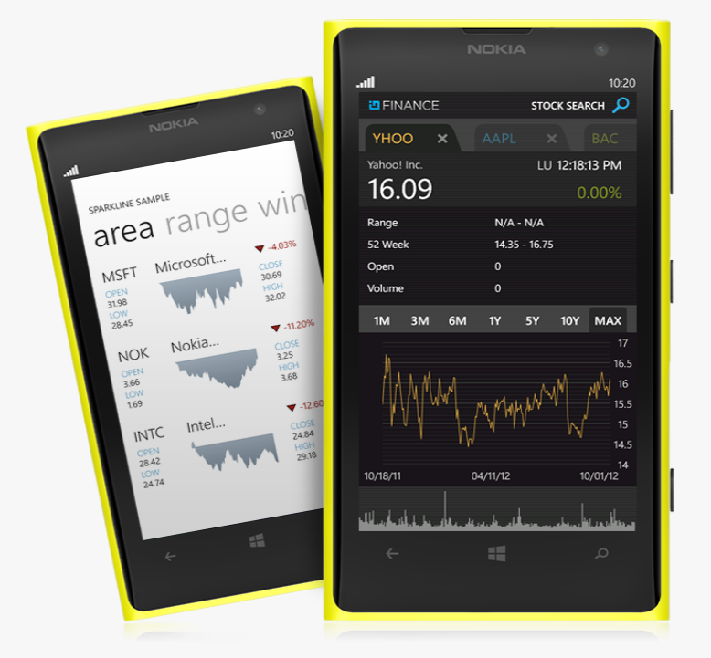 | 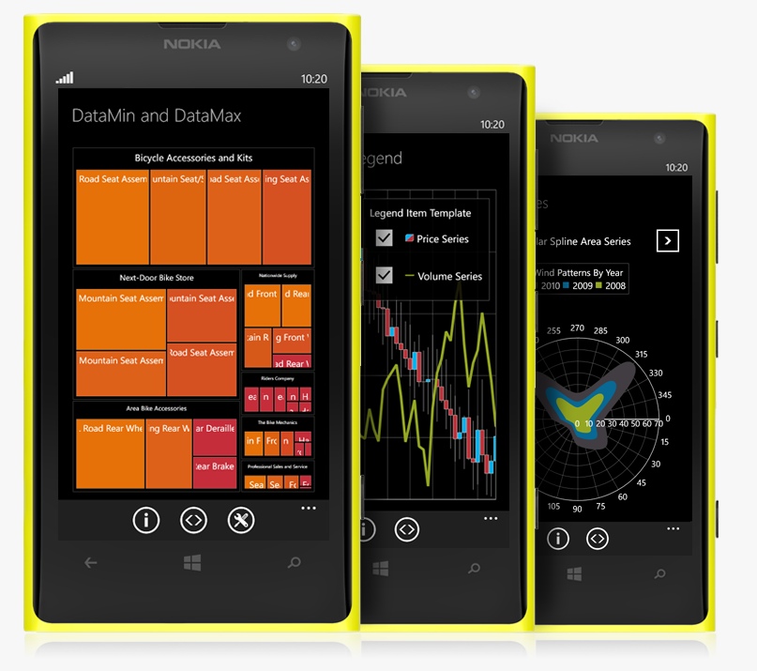

Installation
Downloading | Download Infragistics Controls for Windows Phone here.
Installation Prerequisites | Before you install Infragistics Controls for Windows Phone, make sure you have the following:  Prerequisite Description  Windows Phone 8 SDK Download and Install Windows Phone 8 SDK for Windows from Microsoft© website.

What’s Changed
Components | Product Impact | Description
Auto Complete Box | Bug Fix | Auto Complete Box doesn't provide suggestions when only one char is typed.
General | Bug Fix | Exception is thrown when the Windows Phone source code is built.
Installers | Bug Fix | Controls don't show up in the toolbox after Windows Phone installation.
Installers | Bug Fix | Windows Phone Help - missing shortcut in the installation folder.
List Picker | Bug Fix | List Picker items are not aligned to their checkboxes when multiple selection is enabled.
Masked Input | Bug Fix | The caret goes at the beginning of the xamMaskedInput after a symbol deletion.

