INFRAGISTICS Xamarin 17.2 –
Volume Release Notes

Ultimate UI Controls for Xamarin
Fast, full-featured, easy-to-use controls give you the power to create high-performance, cross-platform mobile apps with controls for Xamarin.Forms, Xamarin.iOS, and Xamarin.Android.

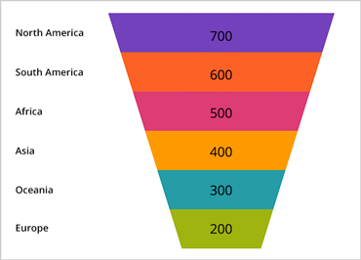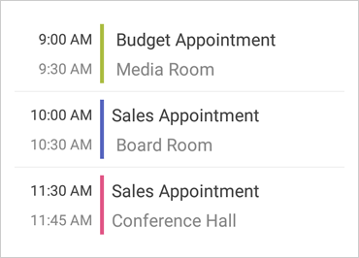

Installation
Downloading | Download Xamarin controls here.

What’s New
Component | Feature Name | Descriptions
Funnel Chart | New Control | A funnel chart is a type of chart that displays quantities as percentages of a whole, much like a pie chart. Funnel charts are commonly used to display quantitative data in relation to stages of a process. For example, a funnel chart might display expenses of a product from the manufacturing stage to the actual sale of that product.
QR Barcode | New Control | The QR (Quick Response) barcode symbology is a matrix (or two-dimensional) code, readable by QR scanners, mobile phones with a camera, and smart phones. This barcode symbology is one of the most popular types of two-dimensional barcodes, as its content can be decoded at high speed.
Doughnut Chart | New Control | The doughnut chart control is similar to the pie chart – proportionally illustrating the occurrences of a variable. The XamDoughnutChart control can display multiple variables in concentric rings. The control provides also slice selection and explosion functionality.
Data Grid | Row Grouping | The XamDataGrid control allows grouping of your rows by a property on your underlying data item.
Data Grid | Row Pinning | The XamDataGrid control allows row pinning by either using keys or the underlying data source items. When a row is pinned, it will show at the top of the data grid and remain fixed there.
Scheduler | New views | The control now has two new views for displaying activities: Day View and Week View.

What’s Changed
Old nuGet package name | New nuGet package name
Infragistics.Core.Barcodes | Infragistics.Xamarin.Barcodes
Infragistics.Core.Charts | Infragistics.Xamarin.Charts
Infragistics.Core.DataGrid | Infragistics.Xamarin.DataGrid
Infragistics.Core.Documents | Infragistics.Xamarin.Documents
Infragistics.Core.Excel | Infragistics.Xamarin.Excel
Infragistics.Core.Gauges | Infragistics.Xamarin.Gauges
Infragistics.Core.Scheduler | Infragistics.Xamarin.Scheduler
Infragistics.Core.Sparkline | Infragistics.Xamarin.Sparkline

Components | Product Impact | Description
Xamarin | Bug Fix | Application crashes setting Culture Info.  Notes:  Use invariant culture when parsing color strings.
Category Chart | Bug Fix | TitleMarginLeft and TitleMarginRight properties have the same effect.
Category Chart | Bug Fix | Setting the BackgroundColor property does not work on Android.  Notes:  The Android XamCategoryChart now respects the value of the BackgroundColor property.
Data Chart | Bug Fix | Zooming is disabled if the Touch event has a new event handler hooked to it.  Notes:  Setting a touch listener on the components will no longer always override the internal touch handling. Returning false from OnTouch will enable the component to handle the event also. Returning true will override the internal handling of the event.
Doughnut Chart | Bug Fix | NullReferenceException is thrown from SkiaSharpCanvasRenderer when OthersCategoryText is set to null.
Funnel Chart | Bug Fix | FormatOuterLabel and FormatInnerLabel properties doesn't work as expected.
Pie Chart | Bug Fix | LabelOuterColor does not render LinearGradientBrush.
Pie Chart | Bug Fix | Legend labels are show as "Series Title" if only the LegendLabelMemberPath is set and not the LabelMemberPath property.
Sparkline | Improvement | Sparkline causes performance issue when scrolling the content of the parent control.  Notes:  Performance optimization was done.
Sparkline | Bug Fix | Axes are not displayed when the axes visibility is set to visible but ItemsSource is not set.
Sparkline | Bug Fix | Sparkline does not render markers with the correct z-index.
Bullet Graph | Bug Fix | Setting interval to .00000001 causes Bullet Graph to crash.
Radial Gauge | Bug Fix | Inner extents of the ranges of the gauge are positioned incorrectly.  Notes:  An incorrect extent value used in the arc calculation has been corrected.
Data Grid | Bug Fix | Exception is thrown when a nullable DateTime column is sorted.
Category Chart | Improvement | It is not possible to show item-specific information in a multi-series category chart tooltip.  Notes:  Added CategoryChart.ToolTipTemplates property.
Mobile Scheduler | Bug Fix | Scheduler visual data contains scaled FontSize properties values.
Mobile Scheduler | Bug Fix | Changing the view mode back to MonthView is throwing an exception.
Mobile Scheduler | Bug Fix | Scheduler's VisualModelExport class does not have DipScalingRatio property.
Mobile Scheduler | Bug Fix | The first digit from the days that contains two digits is not displayed.  Notes:  An issue was resolved in the Scheduler MonthView when running on certain Android devices where 2-digit Day numbers were sometimes being clipped when a bold font was specified for the MonthView Day.

