INFRAGISTICS Silverlight 15.1 –
Service Release Notes – April 2015

Raise the Bar on Both Business Intelligence and Web UI with Infragistics Silverlight Controls.
Infragistics Silverlight controls provide breadth and depth in enabling developers to bring modern, trend-setting applications to market while shortening development time. If you need gesture/touch support, dynamic themes, and lightning fast performance in one Silverlight package, look no further.

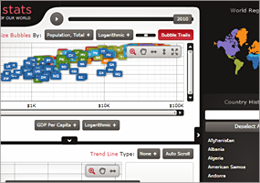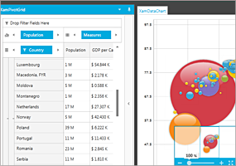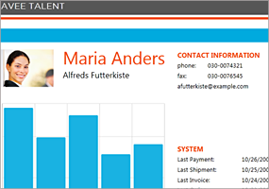

Installation
Downloading | Download Infragistics Ultimate here.
Installation Prerequisites | Before you install Infragistics Ultimate, make sure you have the following:  Prerequisite Description  Silverlight 5 Download and Install Silverlight 5 Developer Runtime for Windows from Microsoft© website.

What’s Changed
Components | Product Impact | Description
Barcode | Bug Fix | The PDF 417 Barcode doesn't appear with the proper height.
Calendar | Bug Fix | The header style is ignored at runtime when it is styled via color tuner.
Color Picker | Bug Fix | Incorrect behavior when adding customized resources.
Combo Editors | Bug Fix | MinDropDownHeight value is ignored when any theme is applied in Silverlight.
Combo Editors | Bug Fix | MinDropDownHeight property breaks the design view in Silverlight.
Data Chart | Bug Fix | StackOverflowException is thrown on loading data.  Notes:  A scenario where certain data shapes on the DateTime x axis would cause a stack overflow exception during data load has been resolved.
Data Chart | Bug Fix | Loading 500 data items throws ArgumentOutOfRangeException when using StackedColumnSeries.  Notes:  A scenario where using UseHighMarkerFidelity with the stacked series would throw an exception has been resolved.
Data Tree | Bug Fix | NullReferenceException is thrown in some cases when changing IsSelectedMemberPath property value.
Data Tree | Bug Fix | The InitializeNode event is not fired for nodes that represent collections.
Data Tree | Bug Fix | Adding a new node clears ActiveNode when is set deeper in the hierarchy.
Data Tree | Bug Fix | The active node becomes null after removing its first child.
Date Navigator View | Bug Fix | The space for the week number is not removed although visibility is set to collapse in xamDateNavigator when a theme is applied.
Excel | Bug Fix | IndexOutOfRangeException is thrown.
Excel | Bug Fix | IndexOutOfRangeException is thrown when loading an .xls file.  Notes:  Fixed an issue in the Excel library where an index out of range exception could be thrown when loading an .xls file.
Excel | Bug Fix | Exception is thrown when saving an Excel that has a named range containing '【】×'.  Notes:  Fixed an issue in the Excel library which could cause an exception when saving a file with named references.
Grid | Bug Fix | The empty value text disappears in Date column if any theme is applied.
Pivot Grid | Bug Fix | Extra item in the toolbox.
Rich Text Editor | Bug Fix | Tables inserted in a list have no in-cells bullets and are not properly aligned.
Rich Text Editor | Bug Fix | A nested table with double border in a table with double borders overlaps the border in one big border.
Rich Text Editor | Bug Fix | Paragraph spacing is increased and differs a lot from MS Word.
Rich Text Editor | Bug Fix | The list indicator is adding too much paragraph spacing.
Rich Text Editor | Bug Fix | Rich Text Editor imports from HTML missing table borders.  Notes:  Fixed two issues in the RichTextDocument where cell borders were not always displaying correctly and cells with no text in HTML were sometimes not being included in the loaded table.
Rich Text Editor | Bug Fix | Pasting in a list is not working when using PlainTextSerializationProvider.
Rich Text Editor | Bug Fix | ImageNode's Transform is not working if RenderSize is set.  Notes:  Fixed an issue in the RichTextDocument where images might not be rotated correctly when their render size is set.
Rich Text Editor | Bug Fix | UpdateSelectionWithSpans throws NullReferenceException when selecting the whole paragraph and replacing its content.
Schedule | Bug Fix | The activity recurrence count is not respected when the interval is greater than 1.
Schedule | Bug Fix | Decimal values for Reminder or Recurrence cannot be set when using German culture.
Tile Manager | Bug Fix | Scrolling doesn’t work smoothly.  Notes:  A TileRetentionMode property has been added to XamTileManager. It defaults to 'Release' which will cause generated tiles that are scrolled out of view to be released which will eliminate unnecessary elements from remaining in the visible tree. This preserves the current behavior.  When TileRetentionMode is set to 'Retain' then generated tiles that are scrolled out of view will be retained in the visual tree to optimize scrolling performance when they are subsequently scrolled back into view.
Tile Manager | Bug Fix | Tile does not show when its visibility is bound to a property from ViewModel and new ViewModel is created.

