INFRAGISTICS Silverlight 15.1 –
Volume Release Notes – 2015

Raise the Bar on Both Business Intelligence and Web UI with Infragistics Silverlight Controls.

Infragistics Silverlight controls provide breadth and depth in enabling developers to bring modern, trend-setting applications to market while shortening development time. If you need gesture/touch support, dynamic themes, and lightning fast performance in one Silverlight package, look no further.

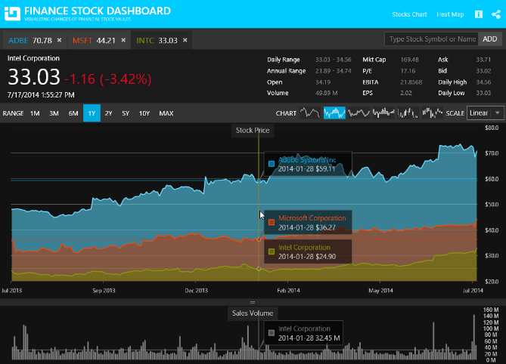
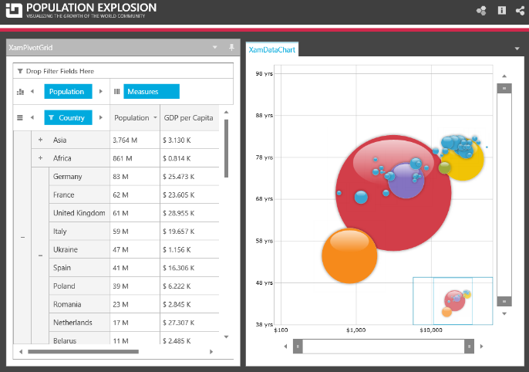
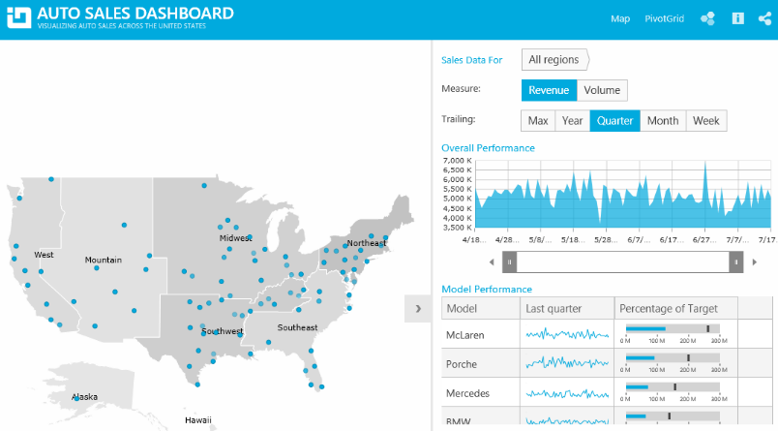

Installation
Downloading | Download Infragistics Controls for Silverlight here.
Installation Prerequisites | Before you install Infragistics Ultimate, make sure you have the following:  Prerequisite Description  Silverlight 5 Download and Install Silverlight 5 Developer Runtime for Windows from Microsoft© website.

What’s New
Component | Feature Name | Descriptions
Combo Editor | Binding to collections of primitive types | The xamComboEditor control supports binding to collections of primitive types such as bool, char, double etc. types. The control supports also binding to enum and collections of string and DateTime data.
Combo Editor | Configuring the minimum drop-down height | A new property MinDropDownHeight is added to provide functionality for configuring the minimum drop-down height of the xamComboEditor control.
MultiColumn ComboEditor | Configuring the minimum drop-down height | A new property MinDropDownHeight is added to provide functionality for configuring the minimum drop-down height of the xamMultiColumnComboEditor control.
Gantt | Sections resizing | The control now supports resizing of the grid and chart sections.

What’s Changed
Components | Product Impact | Description
Calendar | Bug Fix | [Office 2010 Black Theme] The foreground of the selected Calendar Items should be changed.
Color Picker | Improvement | Caption properties are not being set when the control is placed in the ItemTemplate of an ItemsControl.  Notes:  Changes in the way that the xamColorPicker *Caption properties are initialized - the default values are added when the *Caption dependency properties are registered.
Combo Editor | Bug Fix | [Office 2010 Blue theme] XamComboEditor doesn’t show tip text for the error info when it gets the focus.
Combo Editor | Bug Fix | Error disappears after updating the binding.
Combo Editors | Bug Fix | ArgumentException is thrown on close when a theme is set and multi-select combo editor is used.
Combo Editors | Bug Fix | Selection is not cleared when the SelectedValue property is set to a not valid value.
Combo Editors | Bug Fix | The Combo Editors dropdown height is not preserved.
Combo Editors | Bug Fix | Combo Editors drop-down is not always displayed correctly when changing the MaxDropdownHeight in runtime.
Combo Editors | Bug Fix | Resizing does not function properly when the FlowDirection is set to RightToLeft or when in WPF the menus are right-aligned.
Combo Editors | Bug Fix | Combo Editor with wrapped text and selected items throws an exception and its popup is not correctly positioned.
Combo Editors | Bug Fix | NullReferenceException is thrown when binding to ITypedList collection.
Data Chart | Improvement | A first chance exception of type 'System.ArgumentException' occurs when StackedFragmentSeries are added dynamically.  Notes:  A member path scenario with drilling off of an indexer has been added to the supported member path scenarios.
Data Tree | Bug Fix | A node without a child node does not accept a dropped node unless the node previously had a child node.
Data Tree | Bug Fix | Node's IsEnabled visualization is not reflected properly when it is set from the view model.
Data Tree | Bug Fix | When editing a xamDataTree item, the text box is not styled in themes.
Data Tree | Bug Fix | Performance issue when checking all nodes.
Date Navigator View | Bug Fix | [Metro Dark theme] Week Number is not clearly visible when there is a selection.
Date Navigator View | Bug Fix | [Metro Dark theme] Week Number selection is not styled.
Date Time Input | Bug Fix | Validation error is not displayed when ErrorsChanged is invoked.
Dialog Window | Bug Fix | KeyTips are shown when a modal dialog is opened.
Dialog Window | Bug Fix | IsDefault button on a window is still clicked when pressing enter if the modal dialog window is open.  Notes:  Even though the fix prevents the original default button from clicking, there is no way to use a second button with IsDefault property in the XamDialogWindow, as it does not inherit from Window.
Drag and Drop Framework | Bug Fix | A third party ScpEnhancedImageControl cannot be dropped.
Gantt | Bug Fix | Invalid JP date format in a Gantt sample
Geographic Map | Bug Fix | GeographicSymbolSeries do not load.
Grid | Bug Fix | Selected row occasionally changes as the row order is changed by drag and drop operation.
Grid | Bug Fix | InvalidCastException is thrown when accessing the GroupByRow’s ChildBands.  Notes:  The GroupByRow ChildBands collection property is changed to return null because it is not supported by design for a row of type GroupByRow.
Grid | Breaking Change (Other) | Cannot change a Hidden column's visibility by using the column chooser if a column belongs to a group column.  Notes:  Until now, when you try to collapse the last visible column in a group, its parent column is collapsed and the child column remains visible. Now, this behavior is changed – if you collapse the last visible child column - it is collapsed as well as its parent column.  The other change is when you switch the visibility of a parent column from collapsed to visible – the parent column becomes visible as well as all its children columns.
Grid | Bug Fix | Application crashes when the control is in a ChildWindow and the AllowToolTips property is set to Overflow.
Grid | Bug Fix | NullReferenceException is thrown, when clearing the filter through the clear filter button after ungrouping.
Grid | Bug Fix | The filter menu shows the items of ComboBoxColumn using the SelectedValuePath.  Notes:  A new converter property named FilterMenuItemConverter of type IValueConverter is added for the xamGrid ComboBoxColumn and MultiColumnComboColumn to provide an easy way for converting the displayed items text in the filter menu.
Grid | Bug Fix | [Metro Dark theme] Fixed column's drop area is not visible.
Grid | Bug Fix | Row is added after ending edit mode in the FilterRow.
Grid | Bug Fix | The horizontal scroller stays visible after resizing the window when there are only Fixed columns.
Grid | Bug Fix | Memory leak when a filter is applied and the parent window is closed.
Grid | Bug Fix | NullReferenceException is thrown when changing the theme after showing the filter menu.
Grid | Bug Fix | NullReferenceException is thrown on bound data PropertyChanged notification.
MultiColumn Combo | Bug Fix | [Metro Dark theme] The editor caret is not visible.
MultiColumn Combo | Bug Fix | XamMultiColumnCombo does not keep the foreground of the selected item when hovered.
MultiColumn Combo | Bug Fix | Inconsistent scrolling behavior when one row has wrapped content.  Notes:  The main scrolling problem of items with different height is resolved but there still could be seen some undesired blinking when scrolling due to the virtualization in the XamComboEditor.
MultiColumn Combo | Bug Fix | Exception is thrown when a custom property descriptor uses type Double.
Pivot Grid | Bug Fix | ArgumentNullException is thrown when loading customizations with hierarchy which no longer exists in the data source.
Pivot Grid | Bug Fix | The ResultChanged event is not raised when loading a large amount of data.
Pivot Grid | Bug Fix | The CellEdited event does not fire when the application is being closed.  Notes:  The xamPivotGrid doesn't automatically save the unsaved changes on window closing. The desired behavior can be achieved handling the window closing event as follows:  private void Window_Closing(object sender, System.ComponentModel.CancelEventArgs e)  {  var control = pivotGrid.EditSettings.Editor as PivotEditControl;  if (control == null)  return;  if (control.IsInEditMode)  {  control.ExitEditMode(true, false);  }  }
Ribbon | Bug Fix | [Metro Dark theme] A border line is missing in the ribbon menu.
Rich Text Editor | Bug Fix | Image is not exported to RTF.  Notes:  Fixed an issue with the RichTextDocument where RTF files saved and opened in WordPad on a Windows 7 machine would not display images.
Rich Text Editor | Bug Fix | Title numbering is lost when a word document is exported to RTF.  Notes:  Fixed an issue with the RTF saving of the RichTextDocument where the list numbers might not appear correctly when the file is opened.
Rich Text Editor | Bug Fix | Font is not applied to Japanese text.  Notes:  Fixed an issue with the RichTextDocument where Japanese text was not getting affected when applying a font to the current selection.
Schedule | Bug Fix | The reminder combo box is not styled in all themes except in the Metro Dark theme.
Schedule | Bug Fix | [Office 2013 theme] The selection of reminder ComboBox in the activity dialog should not have borders.
Schedule | Bug Fix | NullReferenceException is thrown multiple times when null DateRecurrenceRuleBase is added to the Rules collection.  Notes:  Fixed an issue in the Schedule library where null entries were allowed to be added to the DateRecurrence.Rules collection.
Tree | Bug Fix | [Metro theme] xamTree is transparent.

