INFRAGISTICS Silverlight 15.2 –
Service Release Notes – December 2015

Raise the Bar on Both Business Intelligence and Web UI with Infragistics Silverlight Controls.
Infragistics Silverlight controls provide breadth and depth in enabling developers to bring modern, trend-setting applications to market while shortening development time. If you need gesture/touch support, dynamic themes, and lightning fast performance in one Silverlight package, look no further.

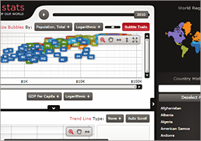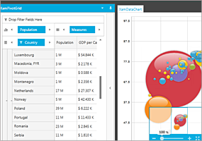

Installation
Downloading | Download Infragistics Ultimate here.
Installation Prerequisites | Before you install Infragistics Ultimate, make sure you have the following:  Prerequisite Description  Silverlight 5 Download and Install Silverlight 5 Developer Runtime for Windows from Microsoft© website.

What’s Changed
Components | Product Impact | Description
Combo Editor | Bug Fix | Dropdown height is shrunk when binding to a new collection and opening the dropdown by using the keyboard down arrow key.
Combo Editor | Bug Fix | The items content is not stretched when the XamComboEditor ItemTemplate is used and the content HorizontalAlignment is set to Stretch.
Combo Editors | Bug Fix | Cannot tab to shared combo editors in a TabControl.
Combo Editors | Bug Fix | The SelectionChanged event is not fired correctly when setting SelectedValues.
Data Chart | Bug Fix | XamDataChart - setting the CursorPosition of the ItemToolTipLayer does not work.  Notes:  Resolved an issue where setting the CrosshairVisibility property at runtime would clear the position of an Annotation with a user-defined position. This would also happen when loading the default CrosshairVisibility setting from generic.xaml.
Date Time Input | Bug Fix | XamDateTimeInput's redo operation is not working when it's done after the value is empty.  Notes:  Resolved an issue in the XamMaskedInput and XamMaskedEditor controls that incorrectly processed the Undo and Redo operations in certain situations resulting in incorrect characters being displayed.
General | Bug Fix | Visual Studio 2015 version is not mentioned in the help root pages for Silverlight and WPF.
Grid | Bug Fix | Scroll position is incorrect when using hierarchical data and user clicks the bottom cell.
Grid | Bug Fix | Incorrect scrolling behavior when scrolling to the bottom of grouped hierarchies.
Network Node | Bug Fix | ArgumentOutOfRangeException is thrown when the window height is close to zero.
Rich Text Editor | Bug Fix | Bullet list indent is not reset after using Ctrl+A and then deleting the existing bullet list.
Rich Text Editor | Bug Fix | Typing 'a', 'y', 'k', 'v' on a new line is removing the applied settings from the previous paragraph.  Notes:  Resolved an issue in the XamRichTextEditor where character formatting from the previous paragraph was sometimes lost when typing certain characters into a newly inserted paragraph.
Rich Text Editor | Bug Fix | The caret does not change its style at the start position and in a new paragraph when typing some content with styles (like Italic, Subscript, and Superscript).  Notes:  Resolved an issue in the XamRichTextEditor where the Caret was not being rendered at a slight 'forward' angle when it was at a character position formatted as italic. The caret is now also correctly sized and positioned when it is at a character position that is formatted as superscript or subscript.
Schedule Outlook Calendar View | Bug Fix | XamOutlookCalendarView does not get the focus, when calling its Focus method.
Tile Manager | Bug Fix | Cannot select an item in the dropdown that is positioned over the XamTile resize border.  Notes:  Resolved an issue in XamTileManager that occurred when clicking on a combo dropdown that overlays the border of a Tile in such a way that the click point in the popup is over the Tile's border. In this scenario, the mouse-down event was being 'stolen' by the XamTileManager to initiate a Tile resize operation and not making its way to the control that displayed the dropdown in the first place. Specifically, this was reported against a XamDateTimeEditor contained in a XamTile.

