INFRAGISTICS Silverlight 16.1 –
Service Release Notes – December 2016

Raise the Bar on Both Business Intelligence and Web UI with Infragistics Silverlight Controls.
Infragistics Silverlight controls provide breadth and depth in enabling developers to bring modern, trend-setting applications to market while shortening development time. If you need gesture/touch support, dynamic themes, and lightning fast performance in one Silverlight package, look no further.

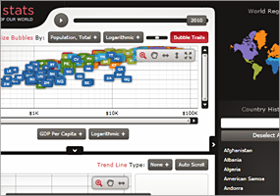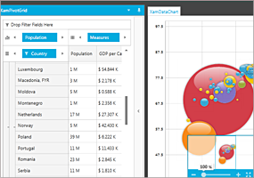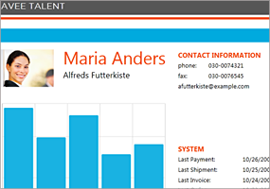

Installation
Downloading | Download Infragistics Ultimate here.
Installation Prerequisites | Before you install Infragistics Ultimate, make sure you have the following:  Prerequisite Description  Silverlight 5 Download and Install Silverlight 5 Developer Runtime for Windows from Microsoft© website.

What’s Changed
Work Item ID | Components | Product Impact | Resolved date | Description
189127 | Data Tree | Bug Fix | 10/11/2016 | SelectedDataItems are not updated correctly when removing a selected node.
189130 | Data Tree | Bug Fix | 10/11/2016 | SelectedDataItems are not updated when setting the ItemsSource property to null.
224550 | Dock Manager | Bug Fix | 10/5/2016 | When adding multiple panes dynamically to DocumentContentHost, sometimes the panes start floating.
226874 | Excel | Bug Fix | 10/21/2016 | The UI hangs when loading a file.
227735 | Excel | Bug Fix | 10/24/2016 | BorderColor for the merged cell region is loaded as Automatic when it should have been Black.
212084 | Grid | Bug Fix | 11/16/2016 | XamGrid does not scroll to the active cell in the last row when the row is added and the cell is set as active in the code behind.
226838 | Grid | Improvement | 10/25/2016 | CellExporting-related events return null for e.XamGrid when exporting to Excel.  Notes:  Added a XamGrid parameter to the ExcelExporterCellExportingEventArgs constructor. A value is provided for this parameter in the following cell-related event args derived classes: GroupByRowCellExportingEventArgs,XamGridExcelExporterCellExportingEventArgs and XamGridExcelExporterColumnLayoutHeaderRowCellExportingEventArgs.
229436 | Multi Column Combo | Bug Fix | 12/1/2016 | Application freezes when re-opening the XamMultiColumnComboEditor without set width and after changing the window size.
226338 | Tile Manager | Bug Fix | 11/1/2016 | Script error LayoutCycleException occurs when you quickly change the browser's height by mouse drag.
229244 | Tile Manager | Bug Fix | 12/5/2016 | Tile cannot be reached by horizontal scroll after tile resize operation.
200733 | Virtual Collection | Bug Fix | 11/9/2016 | Grouping of XamGrid does not work when the control is bound to a Virtual Collection.

