INFRAGISTICS Silverlight 14.2 –
Service Release Notes – June 2015

Raise the Bar on Both Business Intelligence and Web UI with Infragistics Silverlight Controls.
Infragistics Silverlight controls provide breadth and depth in enabling developers to bring modern, trend-setting applications to market while shortening development time. If you need gesture/touch support, dynamic themes, and lightning fast performance in one Silverlight package, look no further.

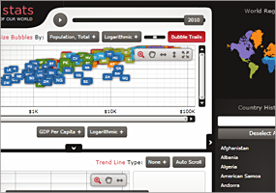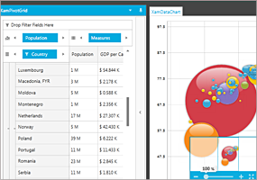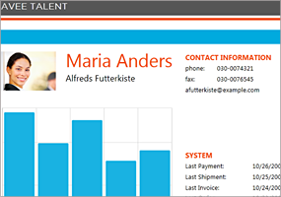

Installation
Downloading | Download Infragistics Ultimate here.
Installation Prerequisites | Before you install Infragistics Ultimate, make sure you have the following:  Prerequisite Description  Silverlight 5 Download and Install Silverlight 5 Developer Runtime for Windows from Microsoft© website.

What’s New
Components | Feature Name | Description
XamItemLegend with  - XamDataChart  - XamDoughnutChart  - XamFunnelChart  - XamPieChart  XamLegend with  - XamDataChart  XamScaleLegend with  - XamDataChart | Unique appearance for Legend’s title and Legend’s items | All chart legends have new properties for specifying separate appearance for title and items such as:  - TitleForeground  - TitleFontSize  - TitleFontFamily  - TitleFontStyle  - TitleFontWeight  - TitleFontStretch  - ItemsForeground  - ItemsFontSize  - ItemsFontFamily  - ItemsFontStyle  - ItemsFontWeight  - ItemsFontStretch
XamItemLegend with  - XamDataChart  - XamDoughnutChart  - XamFunnelChart  - XamPieChart  XamLegend with  - XamDataChart  XamScaleLegend with  - XamDataChart | Alignment of legend’s title and legend’s items | All chart legends have two new properties of positioning/aligning title and items within legends:  - TitleHorizontalAlignment  - TitleVerticalAlignment  - ItemsHorizontalAlignment (except ScaleLegend)  - ItemsVerticalAlignment (except ScaleLegend)  Note that these legend changes do not affect Legacy theme that can be applied to all chart controls because the Legacy theme is still using the following properties instead of new properties:  - Foreground  - FontSize  - FontFamily  - FontStyle  - FontWeight  - FontStretch

What’s Changed
Components | Product Impact | Description
Calendar | Bug Fix | "Today" button text does not change when the Language property is set.
Combo Editor | Bug Fix | The SelectionChanged event is fired again when clicking on an already selected item.
Data Chart | Bug Fix | Setting font related properties does not work on the Legend title and the legend items.  Notes:  Fixed an issue with setting font properties (FontSize, FontFamily, FontWeight, and Foreground) on legend items. In addition, all legends now have new properties for setting appearance of legend title: TitleFontSize , TitleFontFamily , TitleFontWeight , TitleFontStretch, TitleFontStyle, TitleForeground, TitleHorizontalAlignment, TitleVerticalAlignment
Dialog Window | Bug Fix | Controls in a Popup in a modal dialog window are not selectable.
Grid Excel Exporter | Bug Fix | RequireEmptyConstructorException is thrown when exporting XamGrid data bound to a collection of interfaces.
Pivot Grid | Bug Fix | Extra item ("PivotEditControl") appears in the toolbox.
Schedule | Bug Fix | DateNavigator is not synchronized with the outlook calendar when the view is changed to Month.

