INFRAGISTICS Silverlight 15.2 –
Service Release Notes – June 2016

Raise the Bar on Both Business Intelligence and Web UI with Infragistics Silverlight Controls.
Infragistics Silverlight controls provide breadth and depth in enabling developers to bring modern, trend-setting applications to market while shortening development time. If you need gesture/touch support, dynamic themes, and lightning fast performance in one Silverlight package, look no further.

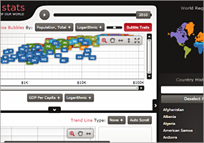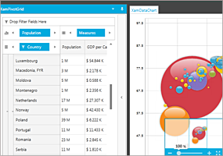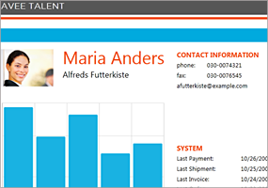

Installation
Downloading | Download Infragistics Ultimate here.
Installation Prerequisites | Before you install Infragistics Ultimate, make sure you have the following:  Prerequisite Description  Silverlight 5 Download and Install Silverlight 5 Developer Runtime for Windows from Microsoft© website.

What’s Changed
Work Item ID | Components | Product Impact | Resolved date | Description
216402 | Context Menu | Bug Fix | 05/19/16 | Managed RuntimeError is thrown after a menu item is dragged to other one.
211845 | Currency Input | Bug Fix | 03/16/16 | Inconsistency between an Input control and an Editor control when performing select all and hitting the ENTER key.
219517 | Data Chart | Bug Fix | 06/08/16 | ArgumentOutOfRangeException is thrown if Interval is set for CategoryDateTimeXAxis.  Notes:  A viewport was not fully initialized due to the timing of the XAML layout cycle which caused the incorrect Ticks to be calculated for a DateTime object. We made sure that there is a fallback viewport in case the expected viewport was not ready.
216557 | Dialog Window | Bug Fix | 05/25/16 | The focused dialog cannot be retrieved on KeyDown.  Notes:  A left mouse button click in the xamDialogWindow area will activate and focus the xamDialogWindow.
219222 | Dialog Window | Bug Fix | 05/20/16 | The active dialog window goes under the other windows.
220222 | Dialog Window | Bug Fix | 06/10/16 | The Click event of a button inside a window does not fire if RestrictInContainer is true.
220223 | Dialog Window | Bug Fix | 06/10/16 | The Click event of a button inside a content pane does not fire at the first click.
219682 | DialogWindow | Bug Fix | 06/13/16 | XamDialogWindowAutomationPeer.IsTopmost should consider ZIndex instead of whether the dialog is active.
217516 | Gantt | Bug Fix | 04/07/16 | Task property mappings may not be used if they are set after the TaskItemsSource is assigned.
220754 | Grid | Bug Fix | 06/20/16 | Horizontal scrollbar is displayed for a grid that has no columns out of view.
220224 | Menu | Bug Fix | 06/10/16 | Child menu does not show when a menu item is clicked for the first time.
212310 | Numeric Input | Bug Fix | 05/26/16 | Min and max inclusive values are not reached when certain SpinIncrement values are set.
218027 | Outlook Bar | Bug Fix | 04/15/16 | Sometimes a XamlParseException is being thrown in SetGroups method in XamOutlookBar's constructor.
216586 | Rich Text Editor | Bug Fix | 03/23/16 | Background is not being serialized if you are not resetting the Document.  Notes:  Resolved an issue in the XamRichTextEditor where the document background (if present) was not always being applied when the content of the current document instance was replaced.
219460 | Tile Manager | Bug Fix | 06/03/16 | Animation stops and StackOverflowException occurs if the tile manager is in a TabControl, the tile contains ScrollViewer and the width of the inside control is set.
219625 | Tile Manager | Bug Fix | 05/25/16 | Tiles get out of order when ShouldAnimate is false.

