INFRAGISTICS Silverlight 16.1 –
Service Release Notes – March 2017

Raise the Bar on Both Business Intelligence and Web UI with Infragistics Silverlight Controls.
Infragistics Silverlight controls provide breadth and depth in enabling developers to bring modern, trend-setting applications to market while shortening development time. If you need gesture/touch support, dynamic themes, and lightning fast performance in one Silverlight package, look no further.

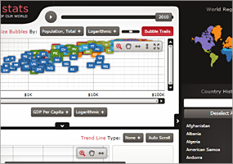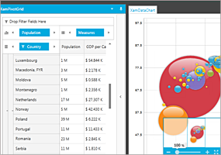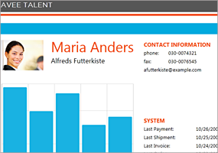

Installation
Downloading | Download Infragistics Ultimate here.
Installation Prerequisites | Before you install Infragistics Ultimate, make sure you have the following:  Prerequisite Description  Silverlight 5 Download and Install Silverlight 5 Developer Runtime for Windows from Microsoft© website.

What’s Changed
Work Item ID | Components | Product Impact | Resolved date | Description
230176 | Data Chart | Bug Fix | 12/20/2016 | Rotating the Y-Axis Labels while extent is set, causes exception.
232200 | Gantt | Bug Fix | 3/20/2017 | When using a ListBackedProject, if Predecessors does not implement INotifyPropertyChanged, InvalidOperationException is thrown.
234133 | Grid | Bug Fix | 3/19/2017 | Unhandled Exception is thrown when a custom filter is repeatedly applied and cleared.
205460 | Pivot Grid | Bug Fix | 9/19/2016 | PivotDataSlicer performance issue when selecting/unselecting 18,484 items.
230726 | Tile Manager | Bug Fix | 3/2/2017 | Tile rotates infinitely on horizontal scroll.
230813 | Tile Manager | Bug Fix | 2/9/2017 | A tile does not appear after the tile height is changed.
230849 | Tile Manager | Bug Fix | 2/16/2017 | Title bar of a tile behind does not appear if NormalModeSettings TileLayoutOrder is VerticalVariable.

