INFRAGISTICS Silverlight 15.2 –
Volume Release Notes – 2015

Raise the Bar on Both Business Intelligence and Web UI with Infragistics Silverlight Controls.

Infragistics Silverlight controls provide breadth and depth in enabling developers to bring modern, trend-setting applications to market while shortening development time. If you need gesture/touch support, dynamic themes, and lightning fast performance in one Silverlight package, look no further.

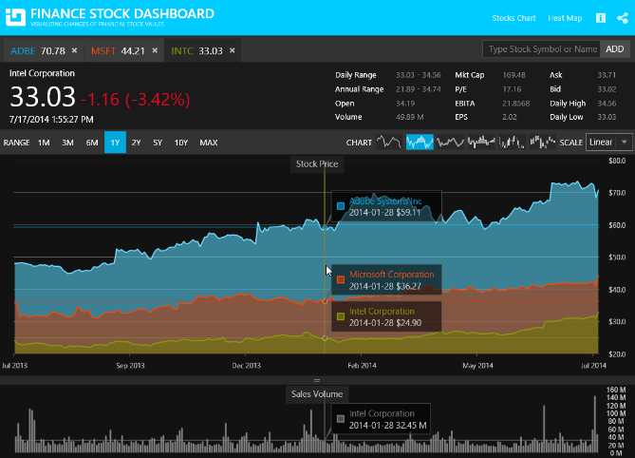
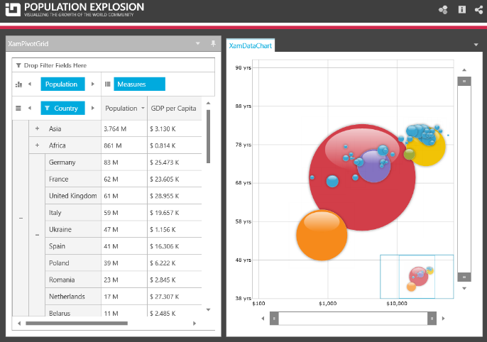

Installation
Downloading | Download Infragistics Controls for Silverlight here.
Installation Prerequisites | Before you install Infragistics Ultimate, make sure you have the following:  Prerequisite Description  Silverlight 5 Download and Install Silverlight 5 Developer Runtime for Windows from Microsoft© website.

What’s New
Component | Feature Name | Descriptions
Infragistics Syntax Parsing Engine | Syntax tree created event | The parsing engine now supports an event which is raised after the syntax tree is created and before it is returned to the text document.
xamDataChart | Major and Minor Axis Intervals | The xamDataChart now supports both Major and Minor intervals which are displayed perpendicular to its axes.
xamDataChart | Legend Title and Items Font | The xamDataChart's Legend, ItemsLegend and ScaleLegend now supports configuration of its font appearances.
xamRichTextEditor | Obtain text insert location from point | The xamRichTextEditor control now supports a method for obtaining the nearest valid text insertion location from the supplied point. The point should be relative to the xamRichTextEditor control.

What’s Changed
Components | Product Impact | Description
Calculation Manager and Data Grid Integration | Bug Fix | Deleting a formula in Formula Editor targeting Field does not clear the Field cell values.
Combo Editor | Bug Fix | InvalidOperationException is thrown when the INotifyDataErrorInfo interface is implemented and the IG theme is applied.  Notes:  Missing XAML elements and visual states added to prevent the exception.
Combo Editor | Bug Fix | Dropdown is displayed in the top left corner when first displayed if INotifyDataErrorInfo is used for validation.
Combo Editor | Bug Fix | InvalidOperationException is thrown on pressing a keyboard key when the control is not focused.
Combo Editor | Bug Fix | Poor performance when selecting all the items of a large ItemsSource.  Notes:  Currently selection of a large number of items one by one is still slow. Fortunately, we have optimized the case when the SelectedItems collection is recreated with the items that should be selected. This approach provides a very fast method to select multiple items at once.  Example:  private void SelectAll()  {  // very fast method to select all items  this.SelectedItems = new ObservableCollection<object>(this.ItemsSource.Cast<object>());  // slow method to select all items  //foreach (var x in Items)  //{  // x.IsSelected = true;  //}  }
Combo Editor | Bug Fix | NullReferenceException is thrown when one editor is focused and another editor is added in a separate UserControl.
Combo Editors | Bug Fix | Combo Editor popup is aligned to the left when the handedness is set to right-handed.
Context Menu | Bug Fix | Cascading menu opens in the wrong direction, when setting the browser zoom to more than 100%.
Context Menu | Bug Fix | Sometimes the popup flickers on the right side of the cursor.
Control Persistence Framework | Bug Fix | ContextMenu is being persisted regardless of SavePersistenceOptions being set to "OnlySpecified." There is an error in the loading of the context menu after that.
Control Persistence Framework | Bug Fix | ArgumentNullException occurs in the output window in debug mode when persisting the xamGrid control and SavePersistenceOptions="AllButIgnored".
Data Chart | Bug Fix | Null property changed event args parameters are not respected by the chart.
Data Chart | Bug Fix | Dark Grey Text on Black background appears for Legend when the Metro Dark theme is applied.
Data Chart | Bug Fix | ArgumentException occurs when using the mouse wheel to scroll up and down.
Data Chart | Bug Fix | SeriesMouseLeftButtonUp does not fire when the user clicks on the series.
Data Tree | Bug Fix | Data Tree leaks node objects when the ItemsSource is set to null.
Data Tree | Bug Fix | Nodes are misplaced when using checkboxes after collapse and re-expansion.
Date Time Input | Bug Fix | Memory leak appears with page navigation and theme.
Dialog Window | Bug Fix | Cannot open a context menu when IsModal = true.
Dialog Window | Bug Fix | The newly opened dialog window goes under the existing dialog window.
Dialog Window | Bug Fix | Modal dialog prevents other WPF windows from being used.
Donut Chart | Bug Fix | Memory leak appears in XamDoughnutChart.  Notes:  The way donut chart handles the slices creation causes memory leak when the items source is changed.
Donut Chart | Bug Fix | Memory leak detected when DataContext is continuously reset.  Notes:  The way donut chart handled the slices creation caused memory leak when the items source had changed.
Excel | Bug Fix | ArgumentException is thrown when loading an XLS file into a workbook.
Excel | Bug Fix | Excel framework formula produces #NAME? error when opened in Excel.
Formula Editor | Bug Fix | Formula Editor memory leak appears when switching views.  Notes:  Resolved an issue in the XamFormulaEditor which could cause a rooting issue in Silverlight if the control was unloaded and loaded multiple times.
Formula Editor | Bug Fix | Initial value of the property bound to Formula property does not show.  Notes:  As part of this fix is added an IsVisibleInFormulaEditorDialog bool? property to the ControlCalculationSettings class. By default now elements inside templates will not be displayed in the FormulaEditorDialog unless the XamCalculationManager instance has the same TemplatedParent. The new property is exposed so an application can override this default behavior.
Grid | Bug Fix | Columns cannot be moved by drag and drop.
Grid | Bug Fix | Only the items of the grid that the user is operating on are displayed as filter items.
Grid | Bug Fix | The header caption disappears when a group column's resize indicator is double clicked.
Grid | Bug Fix | NullReferenceException is thrown when a new row with a null value is added and filtering was applied.
Grid | Bug Fix | NullPointerException is thrown sometimes when the grid is filtered.
Masked Input | Breaking Change (API) | Behavior of the Masked Input control with ValueConstraint of Nullable="False" differs from documentation.  Notes:  There is a new value in the InvalidValueBehavior enumeration – "DisplayErrorMessageAndRevertValue", which is now the default value. While the DisplayErrorMessage retains the value, this one reverts it.
Masked Input | Bug Fix | A small number is not accepted if the caret is on the right side of the last digit.  Notes:  Resolved an issue in the XamMaskedInput and XamNumericInput controls where placing the caret to the right of the rightmost fractional digit and pressing a number key would not result in the number being accepted and displayed when there were 1 or more 'empty' fractional digit locations.
Masked Input | Bug Fix | Pasting is allowed when IsReadOnly property is set to True.
Menu | Bug Fix | Menu item does not open correctly when the zoom level of the browser is set to more than 100%.
Multi Column Combo | Bug Fix | Multi Column Combo Editor filter popup has wrong Height.
Multi Column Combo | Bug Fix | Popup opens in the left top corner of the screen on initial load when IDataErrorInfo is implemented.  Notes:  This issue is caused by a bug in WPF. For more information see the following thread:  http://msdn.developer-works.com/article/11398341/WPF+tooltips+and+comboboxes+are+in+top+left+corner
Multi Column Combo | Bug Fix | No data loaded when all TextComboColumns have Width property set to "*".
Multi Column Combo | Bug Fix | Adding a footer to the multi column combo editor causes a blue bar to appear when filtering.
Pivot Grid | Bug Fix | Slow Pivot Grid performance when loading data from XmlaDataSource.
Pivot Grid | Bug Fix | Performance issue occurs when loading 100000 items through FlatDataSource.
Pivot Grid | Bug Fix | TargetInvocation exception is thrown when there are DBNull columns.  Notes:  When there is not data for the cube last updated time and last processed time, the adomd data provider failed to load a cube from the database.
Pivot Grid | Bug Fix | An item in the dataselector can't be dragged when using the Office2010Blue Theme.
Pivot Grid | Bug Fix | After loading customizations on a large XmlaDataSource, the wrong number of dimensions is shown.  Notes:  When there are more than 2 stored filters in the predefined file, it was possible to load all filter members at same time. So due to the limit of 2 connection to the server at the same time, we limited the number of requests to 2.
Pivot Grid | Bug Fix | After loading customizations of a large XmlaDataSource, the expandable dimensions in the same row as the filtered in dimension do not expand correctly.  Notes:  Fixed issue where in some cases the data source did not expand hierarchy when an advanced filter is applied.
Pivot Grid | Bug Fix | After loading customizations on a large XmlaDataSource, the removal of a dimension occasionally does not work correctly.  Notes:  Fixed issue where in some cases the data source did not expand hierarchy when an advanced filter is applied.
Pivot Grid | Bug Fix | After loading customizations on a large XmlaDataSource, the removal of a filter is not working correctly.  Notes:  Fixed issue where in some cases the data source did not expand hierarchy when an advanced filter is applied.
Rich Text Editor | Bug Fix | The opening of an empty document is throwing an exception.  Notes:  Resolved an issue in RichTextDocument which resulted in an exception being thrown when opening a document with zero length contents. Now no exception is thrown and an empty document is returned.
Rich Text Editor | Bug Fix | The GetPositionFromPoint method returns null for text in the table cells.
Rich Text Editor | Bug Fix | The GetPositionFromPoint method returns null when the SnapToText is set to true and the point is 0 or not within the control's boundaries.
Rich Text Editor | Bug Fix | The GetPositionFromPoint method returns null when the editor is zoomed in few times.
Rich Text Editor | Bug Fix | The GetPositionFromPoint method returns null in a paragraph with a drop cap.
Rich Text Editor | Bug Fix | Pasted HTML with empty row adds a large empty row in the rich text editor.  Notes:  Fixed bug in Html serializer that was adding extra before and after paragraph spacing when de-serializing table cells with no content.
Rich Text Editor | Bug Fix | The caret does not change its style when typing some content with styles (like Italic, Subscript and etc.).  Notes:  Resolved an issue in the XamRichTextEditor where the Caret was not being rendered at a slight 'forward' angle when it was at a character position formatted as italic.
Rich Text Editor | Bug Fix | Deselecting a paragraph marked via the mouse is deselecting also the last character.
Schedule | Bug Fix | Reminders do not open when AppointmentItemsSource is set after the schedule initialization is complete.  Notes:  Resolved an issue in XamSchedule where the reminder dialog was not displaying for Appointments that were created in code and added to the associated DataConnector's AppointmentItemsSource if the DataConnector's AppointmentItemsSource property was set AFTER the XamScheduleDataManager was loaded/initialized and IMMEDIATELY BEFORE the Appointment was added to the AppointmentItemsSource.
Schedule | Bug Fix | Empty Item appears in dropdown in RecurrenceDialog.
Schedule | Bug Fix | Confusing message appears for yearly recurrence.
Schedule Outlook Calendar View | Bug Fix | DateNavigator is not synchronized with XamOutlookCalendarView.
Slider | Bug Fix | Thumbs cannot be moved when the thumb values are equal and InteractionMode is Lock.
Syntax Editor | Improvement | The squiggly for an added diagnostic is not shown when the length of the TextSpan is greater than the length of the line.  Notes:  Added support for multi-line syntax error adornments in the XamSyntaxEditor. Also resolved an issue in the XamSyntaxEditor when modifying text to correct an existing syntax error that sometimes resulted in a flicker, with the error squiggly disappearing upon typing but reappearing briefly before disappearing for good.
Syntax Editor | Bug Fix | Binding expression error: "'TextOptions' property not found" on startup.  Notes:  Resolved an issue in the WPF version of the XamSyntaxEditor which resulted in a BindingExpression error for the 'TextOptions' property appearing in the Visual Studio output window. The error no longer appears.
Tile Manager | Bug Fix | The Tile does not stick to the mouse pointer while dragging.

