INFRAGISTICS Silverlight 15.1 –
Service Release Notes – September 2015

Raise the Bar on Both Business Intelligence and Web UI with Infragistics Silverlight Controls.
Infragistics Silverlight controls provide breadth and depth in enabling developers to bring modern, trend-setting applications to market while shortening development time. If you need gesture/touch support, dynamic themes, and lightning fast performance in one Silverlight package, look no further.

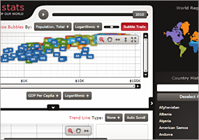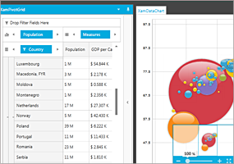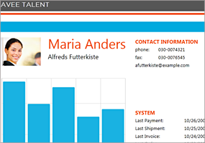

Installation
Downloading | Download Infragistics Ultimate here.
Installation Prerequisites | Before you install Infragistics Ultimate, make sure you have the following:  Prerequisite Description  Silverlight 5 Download and Install Silverlight 5 Developer Runtime for Windows from Microsoft© website.

What’s Changed
Components | Product Impact | Description
Context Menu | Bug Fix | Cascading menu opens in the wrong direction, when setting the browser zoom to more than 100%.
Control Persistence Framework | Bug Fix | ContextMenu is being persisted regardless of SavePersistenceOptions being set to "OnlySpecified." There is an error in the loading of the context menu after that.
Date Time Input | Bug Fix | Memory leak appears with page navigation and theme.
Dialog Window | Bug Fix | The newly opened dialog window goes under the existing dialog window.
Formula Editor | Bug Fix | Formula Editor memory leak appears when switching views.  Notes:  Resolved an issue in the XamFormulaEditor which could cause a rooting issue in Silverlight if the control was unloaded and loaded multiple times.
Grid | Bug Fix | NullReferenceException is thrown when a new row with null value is added and filtering was applied.
Grid | Bug Fix | Only the items of the grid that the user is operating on are displayed as filter items.
Masked Input | Breaking Change (API) | Behavior of the Masked Input control with ValueConstraint of Nullable="False" differs from documentation.  Notes:  There is a new value in the InvalidValueBehavior enumeration – "DisplayErrorMessageAndRevertValue", which is now the default value. While the DisplayErrorMessage retains the value, this one reverts it.
Masked Input | Bug Fix | Pasting is allowed when IsReadOnly property is set to True.
Masked Input | Bug Fix | A small number is not accepted if the caret is on the right side of the last digit.  Notes:  Resolved an issue in the XamMaskedInput and XamNumericInput controls where placing the caret to the right of the rightmost fractional digit and pressing a number key would not result in the number being accepted and displayed when there were 1 or more 'empty' fractional digit locations.
Menu | Bug Fix | Menu item does not open correctly when the zoom level of the browser is set to more than 100%.
Pivot Grid | Bug Fix | Slow Pivot Grid performance when loading data from XmlaDataSource.
Pivot Grid | Bug Fix | An item in the dataselector can't be dragged when using the Office2010Blue Theme.
Rich Text Editor | Bug Fix | The GetPositionFromPoint method returns null when the SnapToText is set to true and the point is 0 or not within the control's boundaries.
Rich Text Editor | Bug Fix | The GetPositionFromPoint method returns null when the editor is zoomed in few times.
Rich Text Editor | Bug Fix | The GetPositionFromPoint method returns null in a paragraph with a drop cap.
Rich Text Editor | Bug Fix | The GetPositionFromPoint method returns null for text in the table cells.
Rich Text Editor | Bug Fix | The opening of an empty document is throwing an exception.  Notes:  Resolved an issue in RichTextDocument which resulted in an exception being thrown when opening a document with zero length contents. Now no exception is thrown and an empty document is returned.
Rich Text Editor | Bug Fix | Pasted HTML with empty row adds a large empty row in the rich text editor.  Notes:  Fixed bug in Html serializer that was adding extra before and after paragraph spacing when de-serializing table cells with no content.
Rich Text Editor | Bug Fix | Deselecting the paragraph mark via the mouse is deselecting also the last character.
Schedule | Bug Fix | Reminders do not open when AppointmentItemsSource is set after the schedule initialization is complete.  Notes:  Resolved an issue in XamSchedule where the reminder dialog was not displaying for Appointments that were created in code and added to the associated DataConnector's AppointmentItemsSource if the DataConnector's AppointmentItemsSource property was set AFTER the XamScheduleDataManager was loaded/initialized and IMMEDIATELY BEFORE the Appointment was added to the AppointmentItemsSource.
Schedule | Bug Fix | Empty Item appears in dropdown in RecurrenceDialog.
Schedule | Bug Fix | Confusing message appears for yearly recurrence.
Schedule Outlook Calendar View | Bug Fix | DateNavigator is not synchronized with XamOutlookCalendarView.
Syntax Editor | Improvement | The squiggly for an added diagnostic is not shown when the length of the TextSpan is greater than the length of the line.  Notes:  Added support for multi-line syntax error adornments in the XamSyntaxEditor. Also resolved an issue in the XamSyntaxEditor when modifying text to correct an existing syntax error that sometimes resulted in a flicker, with the error squiggly disappearing upon typing but reappearing briefly before disappearing for good.
Tile Manager | Bug Fix | Maximize, minimize and close buttons do not work after clearing and re-adding the tiles to the Tile Manager.

