INFRAGISTICS Silverlight 15.2 –
Service Release Notes – September 2016

Raise the Bar on Both Business Intelligence and Web UI with Infragistics Silverlight Controls.
Infragistics Silverlight controls provide breadth and depth in enabling developers to bring modern, trend-setting applications to market while shortening development time. If you need gesture/touch support, dynamic themes, and lightning fast performance in one Silverlight package, look no further.

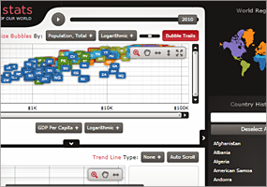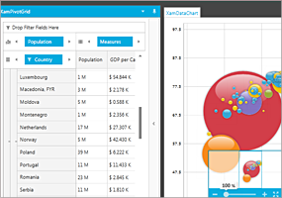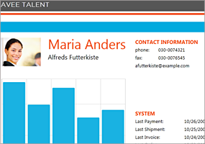

Installation
Downloading | Download Infragistics Ultimate here.
Installation Prerequisites | Before you install Infragistics Ultimate, make sure you have the following:  Prerequisite Description  Silverlight 5 Download and Install Silverlight 5 Developer Runtime for Windows from Microsoft© website.

What’s Changed
Work Item ID | Components | Product Impact | Resolved date | Description
222956 | Combo Editor | Bug Fix | 8/11/2016 | Focus does not move properly if another application window is activated.
222080 | Data Chart | Bug Fix | 7/15/2016 | ArgumentException occurs when a value overlay is present and setting the Legend on the chart in a dock manager.  Notes:  An exception has been corrected in the ValueOverlay class.
219878 | Data Tree | Bug Fix | 6/14/2016 | ActiveNode is null at NodeDragEnd event.  Notes:  The xamDataTree ActiveDataItem won't be reset while dragging the item.
220864 | Dialog Window | Bug Fix | 7/8/2016 | Dialog doesn't resize properly when it is restricted in a container.  Notes:  Remove some logic above, where the container coordinates were assigned opposite (negative) values, which was leading to an incorrect calculation below.
220864 | Dialog Window | Bug Fix | 7/8/2016 | Also rework the calculation to make sure once the right side of the container is reached, the width remains constant, therefore the dialog cannot be resized outside the container.
221605 | Dialog Window | Bug Fix | 7/8/2016 | Modal dialog doesn't behave correctly while being resized leftwards when restricted in a container.
221606 | Dialog Window | Bug Fix | 7/11/2016 | Non modal dialog doesn't behave correctly while being resized leftwards when restricted in a container.
222943 | Dock Manager | Bug Fix | 8/4/2016 | XamlParseException is thrown when dynamically adding a nested XamDockManager that has a pane with IsMaximized set to true.
220380 | Grid | Bug Fix | 7/8/2016 | [Horizontal Scrolling] Child row's horizontal scroll is not smooth.
220762 | Grid | Bug Fix | 9/2/2016 | [Horizontal Scrolling] Column width is not correctly calculated upon column resizing by double clicking the column border.
221078 | Grid | Bug Fix | 7/7/2016 | [Horizontal Scrolling] Header height is too large.
220912 | Grid | Bug Fix | 8/9/2016 | [Horizontal Scrolling] Horizontal scroll position changes as the host area resizes.
220759 | Grid | Bug Fix | 9/7/2016 | [Horizontal Scrolling] Scroll thumb of the horizontal scrollbar stays visible when all the visible columns are fixed.
221079 | Grid | Bug Fix | 7/5/2016 | Column header text bound to a view model property value is not updated.

