INFRAGISTICS Silverlight 16.1 –
Service Release Notes – September 2016

Raise the Bar on Both Business Intelligence and Web UI with Infragistics Silverlight Controls.
Infragistics Silverlight controls provide breadth and depth in enabling developers to bring modern, trend-setting applications to market while shortening development time. If you need gesture/touch support, dynamic themes, and lightning fast performance in one Silverlight package, look no further.

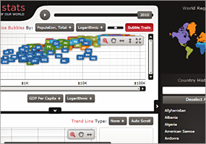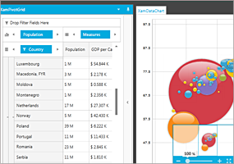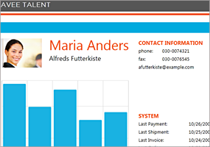

Installation
Downloading | Download Infragistics Ultimate here.
Installation Prerequisites | Before you install Infragistics Ultimate, make sure you have the following:  Prerequisite Description  Silverlight 5 Download and Install Silverlight 5 Developer Runtime for Windows from Microsoft© website.

What’s Changed
Work Item ID | Components | Product Impact | Resolved date | Description
222956 | Combo Editor | Bug Fix | 8/11/2016 15:09 | Focus does not move properly if another application window is activated.
222080 | Data Chart | Bug Fix | 7/15/2016 23:01 | ArgumentException occurs when a value overlay is present and setting the Legend on the chart in a dock manager.  Notes:  An exception has been corrected in the ValueOverlay class.
219878 | Data Tree | Bug Fix | 6/14/2016 10:18 | ActiveNode is null at NodeDragEnd event.  Notes:  The xamDataTree ActiveDataItem won't be reset while dragging the item.
220864 | Dialog Window | Bug Fix | 7/8/2016 18:06 | Dialog doesn't resize properly when it is restricted in a container.  Notes:  Remove some logic above, where the container coordinates were assigned opposite (negative) values, which was leading to an incorrect calculation below. Also rework the calculation to make sure once the right side of the container is reached, the width remains constant, therefore the dialog cannot be resized outside the container.
221605 | Dialog Window | Bug Fix | 7/8/2016 18:17 | Modal dialog doesn't behave correctly while being resized leftwards when restricted in a container.
221606 | Dialog Window | Bug Fix | 7/11/2016 12:13 | Non modal dialog doesn't behave correctly while being resized leftwards when restricted in a container.
222943 | Dock Manager | Bug Fix | 8/4/2016 21:05 | XamlParseException is thrown when dynamically adding a nested XamDockManager that has a pane with IsMaximized set to true.
220380 | Grid | Bug Fix | 7/8/2016 18:23 | [Horizontal Scrolling] Child row's horizontal scroll is not smooth.
220759 | Grid | Bug Fix | 9/7/2016 16:11 | [Horizontal Scrolling] Scroll thumb of the horizontal scrollbar stays visible when all the visible columns are fixed.
220762 | Grid | Bug Fix | 9/2/2016 15:25 | [Horizontal Scrolling] Column width is not correctly calculated upon column resizing by double clicking the column border.
220912 | Grid | Bug Fix | 8/9/2016 11:25 | [Horizontal Scrolling] Horizontal scroll position changes as the host area resizes.
221078 | Grid | Bug Fix | 7/7/2016 17:21 | [Horizontal Scrolling] Header height is too large.
221079 | Grid | Bug Fix | 7/5/2016 11:18 | Column header text bound to a view model property value is not updated.

