INFRAGISTICS Windows Forms 15.2 –
Volume Release Notes – 2015

Raise the Bar on Both BI and Desktop UI with Infragistics Windows Forms Controls

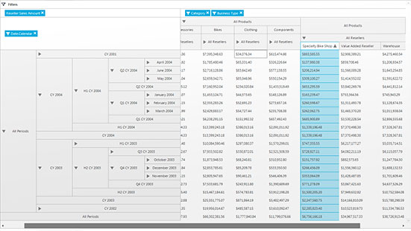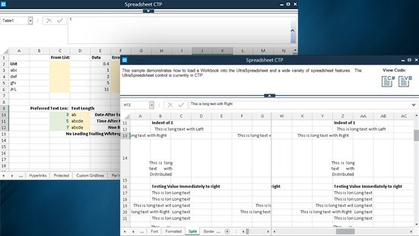Infragistics Windows Forms controls provide complete usability and extreme functionality to your next desktop application. Ensure app adoption when you create the experiences your customers already know, with Microsoft-inspired features that mimic Word, Excel, and Outlook.

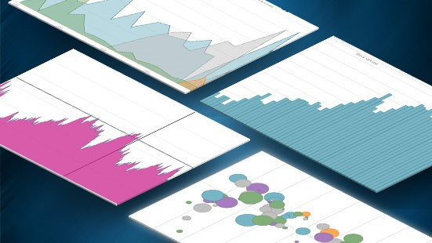

Installation
Downloading | Download Infragistics Controls for WinForms here

What’s New
Component | Feature Name | Descriptions
UltraDataChart | Major and Minor Axis Intervals | The DataChartView's now supports both Major and Minor intervals which are displayed perpendicular to its axes.
UltraDataChart | Saving the Chart | SaveTo method of the element to save an image of the UltraDataChart
UltraDataChart | Scale Legend | Scale Legend maps the color from gradient scale with the value of the chart point.
UltraDataChart | Bubble Series | New bubble series for UltraDataChart
UltraDataChart | Stacked Series | New stacked series for UltraDataChart
UltraDataChart | Polar Series | New Polar series for UltraDataChart
UltraDataChart | Radial Series | New Radial Series for UltraDataChart
UltraDataChart | Numeric Angle Axis | New Numeric Angle Axis in the UltraDataChart
UltraDataChart | Category Angle Axis | New Category Angle Axis in the UltraDataChart
UltraDataChart | Numeric Radius Axis | New Numeric Radios Axis in the UltraDataChart
UltraDataChart | Touch Gesture Support | Touch gestures are interactions with a screen that enables users to navigate and interact with content in the UltraDataChart control.
UltraDataChart | Annotation Layer | Hover interactions are implemented through hover interaction layers which are series that are added to the series collection. These layers are dependent on the cursor position. Adding the hover interaction layers to the UltraDataChart control disables the default behavior of the crosshairs and/or tooltips (depending on which type of layer added)..
UltraDataChart | Category Tooltip Layer | The CategoryToolTipLayer displays grouped tooltips for the series on the UltraDataChart control using a category axis.
UltraDataChart | Item Tooltip Layer | The ItemToolTipLayer displays tooltips for all the series on the UltraDataChart control individually when the mouse hovers over that particular series.
UltraDataChart | Crosshair Layer | The CrosshairLayer renders as crossing lines intersecting at the actual value of every series that they are configured to target with each series rendering a separate set of lines.
UltraDataChart | Category Highlight Layer | The CategoryHighlightLayer targets a category axis, or all category axes in the UltraDataChart control. If the axis contains any series that are aligned between major gridlines of the axis, for example, ColumnSeries series, this will render a shape that fills the current category.
UltraDataChart | Category Item Highlight Layer | The CategoryItemHighlightLayer highlights items in series using category axis by either drawing a banded shape or rendering a marker at that position.
UltraDataChart | Value Overlay | In the UltraDataChart™ control, ValueOverlay is used to overlay a single numeric value as a line over other types of series in order to indicate important values such as mean/median of a data set.
FormattedTextEditor & FormattedLinkLabel | Using Subscript and Superscript | Subscript or Superscript is text that is displayed in a slightly smaller than normal font and is either slightly above or below the normal baseline.
UltraMessageBoxInfo | StartPosition and StartLocation | The StartPosition property specifies the initial position of the dialog from a set of predefined positions (DialogStartPosition Enumeration). If the property is set to DialogStartPosition.Manual, then the location of the UltraMessageBoxManager is determined by the StartLocation property.
UltraWinGrid | New Summary Properties | The DefaultSummaryRowHeight property provides the ability to specify the default height of the summary rows.
UltraToolbarsManager | Notification Badge | The Notification Badges allow you to notify your users about every important event that requires their attention.
UltraPivotGrid | FlatDataSource DataAdapters | The 15.2 release now includes two ancillary classes, located under the new Infragistics.Olap.FlatData.Adapters namespace, which make it possible to connect to a database using either SQL Server or OLEDB technology.
SpreadSheet (CTP) | New Control | The Spreadsheet control allows visualizing and editing of spreadsheet data, represented by the data model supported by the Infragistics Excel Engine.

What’s Changed
Component | Product Impact | Title
Infragistics CodedUI - Editors | Bug Fix | UltraTextEditor's text property does not appear in Coded UI Test Builder
Infragistics Excel Engine | Bug Fix | FormulaParseException is thrown on loading an Excel if there is a cell that has a reference to a worksheet which name contains characters like 【】or 「」 or some MathSymbol Unicode characters.
Infragistics Excel Engine | Bug Fix | Out of Memory Exception when applying formulas with a large amount of a data
Infragistics Excel Engine | Bug Fix | FormulaParseException is thrown when loading an Excel that has a named range containing '?'.
Infragistics Excel Engine | Bug Fix | Exception is thrown when saving an Excel that has a named range containing '【】×'.
Infragistics Excel Engine | Bug Fix | Roundtrip support for pivot grids is not working properly
Infragistics Excel Engine | Bug Fix | ArgumentNull Exception thrown while importing Excel Macro file (xlsm)
Infragistics Excel Engine | Bug Fix | ArgumentException is thrown upon loading Excel.
Infragistics Excel Engine | Bug Fix | Only 65536 rows exported when there is more than 65536 rows in WorkSheet
Infragistics Excel Engine | Bug Fix | Worksheet.Rows.Insert() method never completes if the worksheet contains a shape below the inserting row.
Infragistics Excel Engine | Bug Fix | Exporting both grid and image increases the exporting period hugely
Infragistics Excel Engine | Bug Fix | FormulaParseException is thrown while loading Russian localized excel file
Infragistics Excel Engine | Bug Fix | An EndOfStreamException error occurs when loading an "xls" file.
Infragistics Installer | Bug Fix | Key not found exception when install on a machine with Turkish (Turkey) format settings (Proxy not found on the system)
Infragistics Installer | Bug Fix | NullReferenceException when run platform installer from a server location
Infragistics Installer | Bug Fix | A NullReferenceException occurs when the Platform Installer is run from a network drive.
Infragistics SyntaxParsing | Bug Fix | MissingManifestResourceException is thrown when using the syntax parsing engine
Infragistics Version Utility | Bug Fix | NotSupportedException is thrown when upgrading certain projects
Infragistics WinForms General | Bug Fix | ArgumentException occurs when closing a window that has some IG controls if Protector Suite QL which is a fingerprint reader software is installed on the PC.
Infragistics WinForms General | Bug Fix | There is no way to add a DateHierarchyFilterOperand to a column so that it shows up checked in the FilterUIProvider
UltraDataChart | Bug Fix | FormatException is thrown on some cultures when creating StackedBarSeries
WinChart | Bug Fix | RenderPdfFriendlyGraphics doesn't render the labels for Composite Charts
WinChart | Bug Fix | UltraChart SaveTo method image scales the fonts incorrect
WinChart | Bug Fix | Setting OrientationAngle of the axis labels also causes them to change their location
WinChart | Bug Fix | Loading presets doesn't work with inherited series
WinChart |  | X axis labels duplicated in Composite StackedColumn chart
WinChart | Bug Fix | Series with empty string label, cause the legend items to overlap
WinChart | Bug Fix | System.ArgumentException is thrown when Brushes.Transparent is referenced after the chart is created.
WinCheckEditor | Bug Fix | Control is not dpi aware when using higher dpi(144 dpi)
WinCombo | Bug Fix | System.ArithmeticException on hover
WinCombo | Bug Fix | PageUp action is not changing the selected row
WinCombo | Bug Fix | Embedded combo drop down closes when building a custom filter
WinComboEditor | Bug Fix | Child forms become unresponsive when changing theme after combo editor is dropped down
WinControlContainer | Bug Fix | ApplyOwnerAppearance should be virtual
WinDataSource | Bug Fix | 2 Bands are added to the bound grid after cancel custom property page
WinDateTimeEditor | Bug Fix | Does not accept new value with Japanese regional settings
WinDayView | Bug Fix | NullReferenceException while user drag an appointment
WinDayView | Bug Fix | Copying recurring appointments with Ctrl+Click doesn't work properly
WinDockManager | Bug Fix | Unpinned tab still interact with mouse movement even after display modal dialog when UnpinnedTabHoverAction = None
WinDocumentExporter | Bug Fix | misalignment between header's column width and row's column width when using RowLayoutStyle.ColumnLayout
WinEditors | Bug Fix | Focus is not retained when there is only one enabled control
WinGanttView | Bug Fix | Starting a drag operation to change a task's duration causes the duration to jump unexpectedly
WinGrid | Bug Fix | Cells are not repainted when third-party software like MS UI Automation recorder was run
WinGrid | Bug Fix | Drag to remove column feature is not working in card view, when using certain settings
WinGrid | Bug Fix | Can't add new rows using TemplateAddRow with self-relation data table
WinGrid | Bug Fix | Headers are not aligned correctly when using groups
WinGrid | Bug Fix | Excel filter dialog does not show vertical scroll bar
WinGrid | Bug Fix | StackOverflow exception in UltraGrid with two GroupByColumns
WinGrid | Bug Fix | Ultragrid does not fire BeforeSelectChange and AfterSelectChange on AddRow deselected
WinGrid | Bug Fix | Performance Improvements in UltraWinGrid
WinGrid | Bug Fix | Can't tab through cells when Header.Enabled is set to false for all columns
WinGrid | Bug Fix | CellMultiLine does not force cell repainting in runtime
WinGrid | Bug Fix | Memory leak when scrolling columns
WinGrid | Bug Fix | UltraWinGrid - ColumnFilter lost when loading a GridLayout
WinGrid | Bug Fix | The rows collection is empty when rebinding the grid on a touch device
WinGrid |  | NullReferenceException is thrown when activate cell after PerformAction AboveRow on the first row of grouped grid
WinGrid | Bug Fix | Column header is not accounted for when calculating auto resize width for hidden columns
WinGrid | Bug Fix | PerformAutoResize calculates column width incorrectly for bolded text when ColumnStyle is Double
WinGrid | Bug Fix | NoRowsInDataSource properties only work for band zero
WinGrid | Bug Fix | Horizontal scroll is too slow when UseFixedHeaders is set to true
WinGrid | Bug Fix | Tooltip in DateTime column has no text when using specific theme
WinGrid | Bug Fix | Black line is drawn out of the grid while resizing the column on system with DPI set above 125%
WinGrid | Bug Fix | Tabbing between cells in UltraGrid does not work when the grid is splitted by using ColScrollRegion.
WinGridExcelExporter | Bug Fix | Band.Header.Caption is not exported when ColHeadersVisible is set to false
WinGridExcelExporter | Bug Fix | [Excel Export] The first row is treated as a GridHeader - when formatting
WinGridExcelExporter | Bug Fix | Low performance while exporting huge grid
WinMonthViewSingle | Bug Fix | AfterScroll event is not raised when scrolling horizontally
WinOptionSet | Bug Fix | [StackOverflowException] Crash occurs when setting the CheckedIndex in the ValueChanged Event
WinPictureBox | Bug Fix | wmf is drawn at wrong position
WinPivotGrid | Bug Fix | Dates are sorted as strings, instead of dates
WinPivotGrid | Bug Fix | IndexOutOfRangeException is thrown when rebinding the pivot grid multiple times
WinSchedule | Bug Fix | Recurring appointments with occurrence duration longer than day cause ArgumentOutOfRangeException
WinSpellChecker |  | Exception encountered when spell checking a specific type of string
WinSpellChecker | Bug Fix | IndexAoutOfRange exception when spellchecking words with digits
WinSpellChecker | Bug Fix | Words with wrong case from the UserDictionary are considered correct
WinTabbedMdiManager | Bug Fix | [MDI Manager] Child Form flickers whenresizing controls on mainform
WinTabControl | Bug Fix | Unhandled exception occurs when Tabs.Clear() method is called while the last tab is selected by code.
WinTabControl | Bug Fix | Deleting a tab with a shared ribbon from the designer causes the ribbon to be removed in the rest of the tabs
WinTextEditor | Bug Fix | String which contains tab (\t) overlaps its characters
WinToolbarsManager | Bug Fix | Quick Access Toolbar tooltips contain ampersand
WinToolbarsManager | Bug Fix | ApplicationMenu2010 Keytips aren't shown under some Windows themes
WinToolbarsManager | Bug Fix | ArgumentException parameter is not valid exception is thrown
WinToolbarsManager | Bug Fix | Unhandled exception encountered when using a specific combination of tabs' visible index and form size
WinToolbarsManager | Bug Fix | Status bar is cropped when style is set to Office2013
WinToolbarsManager | Bug Fix | The Ribbon group background flickers when a mouse cursor hovers on the group border.
WinToolbarsManager | Bug Fix | Form Icon gets clipped when ImageSizeSmall is set to 32x32
WinToolbarsManager | Bug Fix | Minitoolbar throws OverflowException when mouse scroll sends wParam with wrong value
WinToolbarsManager | Bug Fix | [Merged Ribbon] Tools are right aligned within an MDI application
WinToolbarsManager | Bug Fix | Merging several instances the same child form will not resolve the RibbonTab's caption based on the active child tab
WinTree | Bug Fix | Indeterminate CheckState is not calculated correctly when NodeStyle is SynchronizedCheckbox
WinTree | Bug Fix | Check state of a parent node doesn't change when Node style is SynchronizedCheckBox

