INFRAGISTICS WINDOWS FORMS 17.2 –
Volume Release Notes – 2017

Infragistics Windows Forms controls provide breadth and depth in enabling developers to bring modern, trend-setting applications to market while shortening development time. If you need gesture/touch support, dynamic themes, and lightning fast performance in one package, look no further.

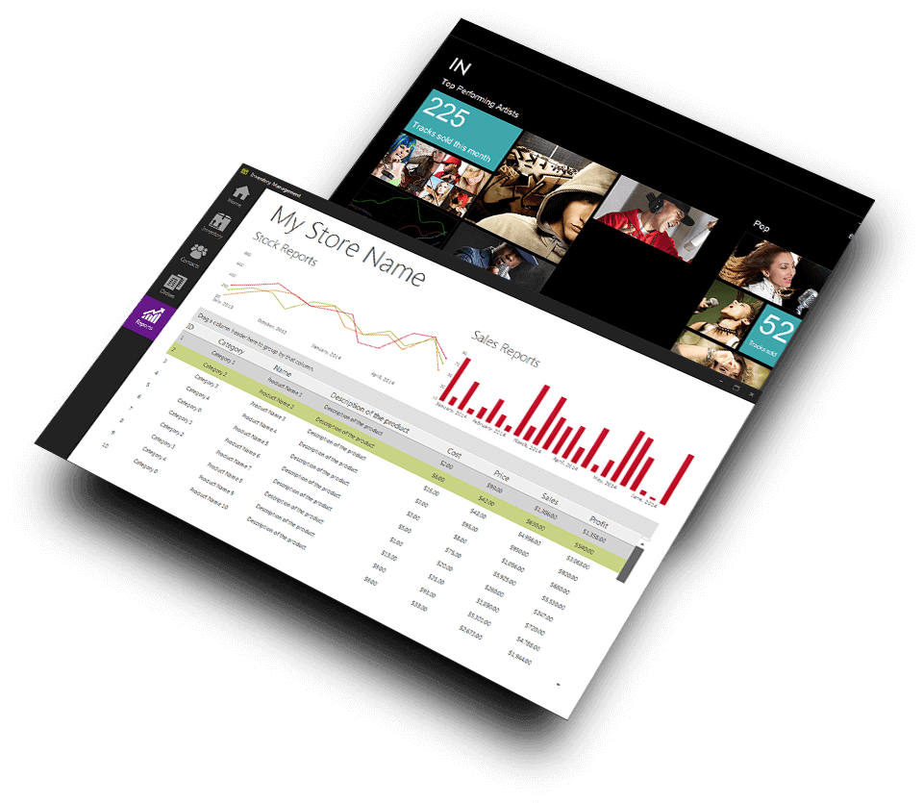 | Top-performing controls for every aspect of software development  Add complete usability and extreme functionality to your next desktop application with the depth and breadth our Windows Forms UI controls. Infragistics Windows Forms continues to make strides in user experience.

Installation
Downloading | Download Infragistics Controls for Windows Forms here

What’s Changed

Components | Product Impact | Description
AppStylist | Bug Fix | Style file does not show selected rows in grid.
CalcManager | Bug Fix | Missing categories from formula builder dialog.
CalcManager | Bug Fix | Applying count formula to grid column of type string is slow.
CalcManager | Bug Fix | Calculation manager fails to parse formula with "\\" in it.
CalendarCombo | Bug Fix | Argument out of range exception is thrown when maximum value is date time's maximum value and three months list is shown.
ComboEditor | Bug Fix | Image displayed on the control is not of the checked item but the last selected item  Notes:  Since it does not make sense to arbitrarily choose one checked item and display the image from that item, the UltraComboEditor will not pick up the image from any selected or checked items when CheckedListSettings are being used.  It is still possible to apply an image using the control's Appearance.Image property.
DataChart | Bug Fix | Null reference exception is thrown while trying to show tooltips.
DataChart | Bug Fix | Whole control area turns to black when move mouse pointer on the control's surface
DataChart | Bug Fix | Changing visibility of the series does not hide or show them.
DataChart | Bug Fix | Cannot set items to display horizontally in legend.
DateTimeEditor | Bug Fix | Unable to bind to parameters in edtior when numpad is used for input.
DateTimeEditor | Bug Fix | Null text appearance property does not exist for the editor.  Notes:  A NullTextAppearance property has been added to UltraDateTimeEditor.
DockManager | Bug Fix | Panel is over all other panels when docked to bottom of the form.
Editors | Bug Fix | Editor in grid cell raises an error when you try to get the UI automation object.
Excel | Bug Fix | Invalid operation exception in specified part does not exist in the package when loading workbook.
Excel | Bug Fix | Workbook throws page break error when an Excel file is loaded.
Excel | Bug Fix | If you use both SumIf and Offset functions in the same formula, the value is not calculated.
Excel | Bug Fix | Newline in an Excel table exports incorrect causing a error on opening in Excel.
Excel | Bug Fix | End of stream exception occurs in load method when it tries loading a 97-2003 Excel file.
Excel | Bug Fix | Cell borders are not copied when rows and columns are inserted in 97-2003 workbook.
Excel | Bug Fix | End of stream exception occurs in load method when it tries loading a 97-2003 Excel file.
Excel | Bug Fix | Problem with function FLOOR.MATH when importing a excel file.
ExcelExporter | Bug Fix | Unbound column with blank key causes object reference exception when exported to Excel.
ExcelExporter | Bug Fix | Each next rows exports slower than previous one when grid has image column.
ExcelExporter | Bug Fix | Circular reference in exported excel file when referring to another grid in a formula.
FormManager | Bug Fix | Form icon displayed in wrong location
FormManager | Bug Fix | Exception is thrown when double clicking on the form icon.
GanttView | Bug Fix | Percent complete is calculated differently as task duration changes.  Notes:  There's not much we can do about this. The PercentComplete property is a float, and it is therefore always going to be imprecise. So the actual value of PercentComplete will always be imprecise.  But it would help if you could format the value and remove the digits after the decimal point. This is what the latest version of MS Project seems to do.  The UltraGanttview currently allows you to Format the PercentComplete column, but not the PercentComplete value in the tooltip. So the tooltip now picks up the column format.  So the column and the tooltip can now be formatted like so:  this.ultraGanttView1.GridSettings.ColumnSettings[TaskField.PercentComplete].Format = "#\\%";
Grid | Bug Fix | Cannot drag selected cells properly including cells from non fixed and fixed columns.
Grid | Bug Fix | Tooltip for date cell is cut off when loading a specific style library.
Grid | Bug Fix | Event is raised three times when not needed
Grid | Bug Fix | Drag selection does not work in the extended area.
Grid | Bug Fix | Grouping by rows when a summary formula defined throws null reference exception
Grid | Bug Fix | Column auto size does not account for data error images.
Grid | Bug Fix | Setting cell spacing cuts off the bottom of multiline text in the cell.
Grid | Bug Fix | Expand all does expand all when it should not.
Grid | Bug Fix | Clicking the cell does not enter in edit mode in specific scenario.
Grid | Bug Fix | Column resizing indicator cannot be hidden.
Grid | Bug Fix | Grid allows the user to copy an invalid string from a cell into drop down list cell.
Grid | Bug Fix | Cell border is noticebale when multiple cells are selected and borders are hidden.
Grid | Bug Fix | An exception is thrown when control's column with more than 5000 rows is filtered.
Grid | Bug Fix | Using fixed headers prints only first page.
Grid | Bug Fix | Grid cell proxy throws an exception when the column is linked to null.
Grid | Bug Fix | Setting fixed cell separator color through style file has no effect in grid.
Grid | Bug Fix | Summaries are not calculated for group by rows that are not in view.
Grid | Bug Fix | After modifying row layout, if the row height is increased, it cannot be reduced by dragging the row separator.
Grid | Bug Fix | Grid cell with mask and no value is too wide when auto sized.
Grid | Bug Fix | In grid setting header placement to fixed and on top causes an error.
ListView | Bug Fix | Vertical scrollbar is shown only for five items  Notes:  Added a new property to the ViewSettingsDetails so you can hide the column headers:  this.ultraListView1.ViewSettingsDetails.ColumnHeadersVisible = false;  The new property was added in v17.1 (and up).
ListView | Bug Fix | Multiple selection throws argument our of range exception.
LiveTileView | Bug Fix | Index out of range exception is thrown when resizing the control.
LiveTileView | Bug Fix | Scrollbar disappears after sometime if the control is not on focus.  Notes:  A new property was added to UltraLiveTileView - AutoHideScrollBar. By default this property is set to true. If one sets it to false the scrollbar will show up and will remain visible.
LiveTileView | Bug Fix | Getting null reference exception when trying to clear application bar buttons.
LiveTileView | Bug Fix | Tile group name is cropped when text rendering mode is set to GDI.
PDF | Bug Fix | Report's publish method freezes up when exporting a particular set of data.
PDF | Bug Fix | Drawing to PDF graphics does not work correctly for some methods.
PivotGrid | Bug Fix | Cannot format the columns in the control.  Notes:  The sample project provided with this bug will not work because the PivotGrid's UseServerFormat defaults to true. So the Format property is never used. You must set UseServerFormat to false, either on the grid or the column in order for the format to have any effect.  Previously, setting UseServerFormat to false caused the cell to appear blank. That issue is now fixed.
PopupControlContainer | Bug Fix | Popup form does not close when is called from model dialog and user click on parent form.
Schedule | Bug Fix | The reminders keep adding if we set a variance prior to its occurence on the same day.
Schedule | Bug Fix | Calendar loads very slowly after setting and resetting a logical day.
Schedule | Bug Fix | Setting the logical day on calendar info object causes unexpected results.
Schedule | Bug Fix | A multilined subject in day view appointment does not always show the multilines.
Schedule | Bug Fix | Mouse wheel does not work properly in all day event area.
Schedule | Bug Fix | Calendar info throws null reference exception when recurring appointments are allowed.
SpellChecker | Bug Fix | Undo function on spell checker dialog does not cause text in control to update.
SpreadSheet | Bug Fix | Null reference exception is thrown when a Japanese character is entered into an active cell
SpreadSheet | Bug Fix | Custom format results in infinite hashtags instead of blank cell.
SpreadSheet | Bug Fix | Control does not wrap the text when cell text does not contain spaces or new lines.
StatusBar | Breaking Change (Visual Appearance) | Control does not honor application styling when ViewStyle is set to Office2007.
TabControl | Improvement | Control resolves hot track selected appearance.  Notes:  HotTrackSelectedAppearance properties have been added to the UltraTabControl, UltraTabStrip, and UltraTab. This properties are hidden from the Properties Windows in 16.2 and 17.1 to avoid designer serialization errors.
Toolbars | Bug Fix | Ampersand character causes undesired ordering in ribbon customization dialog.
ToolbarsManager | Bug Fix | Control does not load some toolbars from a saved layout.
ToolbarsManager | Improvement | Ribbon groups of a Ribbon tab placed only on one screen when Ribbon style is set to Office2013.  Notes:  A new property (MultiMonitorDropDownBehavior) has been added to the UltraToolbarsManager, Ribbon, and MenuSettings classes which can be used to specify how dropdowns behave when spanning multiple screens. This property has been hidden at design-time in 2016 Vol 2.
ToolbarsManager | Improvement | Expose to public access split monitor action propoerty for popup tools.  Notes:  A new property (MultiMonitorDropDownBehavior) has been added to the UltraToolbarsManager, Ribbon, and MenuSettings classes which can be used to specify how dropdowns behave when spanning multiple screens. This property has been hidden at design-time in 2016 Vol 2.
ToolbarsManager | Bug Fix | When multiline tool's caption is not aligned correctly
ToolbarsManager | Bug Fix | Null reference exception after pressing keytip
ToolbarsManager | Bug Fix | Control within container stays visible even when the entire ribbon group is hidden
ToolbarsManager | Bug Fix | Cannot edit the text in text box that was added in tab item toolbar.
ToolbarsManager | Bug Fix | Groups names mismatch when add a new group and form is localized.
ToolbarsManager | Bug Fix | Gallery tool item is not selectable with keyboard operation.
ToolbarsManager | Bug Fix | Argument out of range exception is thrown when double clicking a row.
Tree | Bug Fix | Control's selected nodes contain duplicates with ctrl and shift selection.
Tree | Bug Fix | Control's nodes are out of order after scrolling.
Tree | Bug Fix | Duplicate items in the SelectedNodes collection when you drag-select nodes under different parents.
Tree | Bug Fix | Memory leak when selecting nodes in the tree and then removing them.
Tree | Bug Fix | Editor component is not taken into account when printing the control.
Tree | Bug Fix | Null reference exception is thrown while verifying child elements on removed node.

