Infragistics WinRT 15.1 –

Service Release Notes – December 2015

Build High Performance Business and Engaging Consumer Applications in HTML or XAML
Like Windows 8, Infragistics brings together the best of the PC and tablet in this suite. Impress and innovate with premium controls for data visualization. No matter what the platform or category, apps created with our Windows 8 controls will be bold, high performance and drive revenue through the Windows Store.
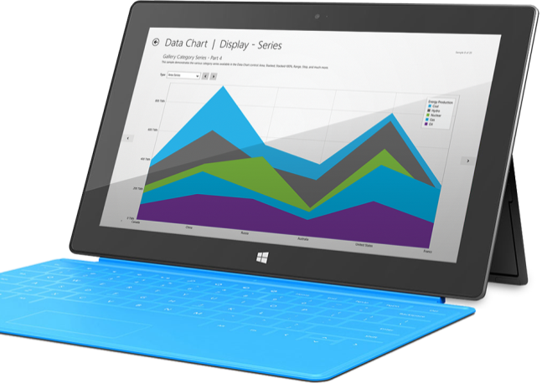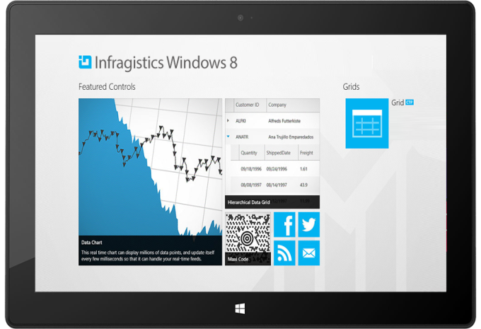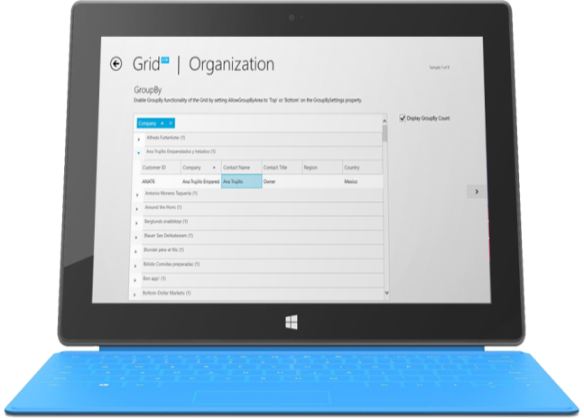

Installation
Downloading | Download Infragistics Ultimate here.

What’s Changed
Components | Product Impact | Description
Data Chart | Bug Fix | XamPieChart is not displayed.  Notes:  Fixed an issue in WinRT where ItemsSources containing Int32 values were not displayed. Fixed an issue in WinRT, which occurred for applications running on Windows 10, where pie slices would not appear due to missing Brushes on their UIElements.

