INFRAGISTICS WPF 15.1 –
Volume Release Notes – 2015

Raise the Bar on Both BI and Desktop UI with Infragistics WPF Controls

Infragistics WPF controls provide breadth and depth in enabling developers to bring modern, trend-setting applications to market while shortening development time. If you need gesture/touch support, dynamic themes, and lightning fast performance in one WPF package, look no further.
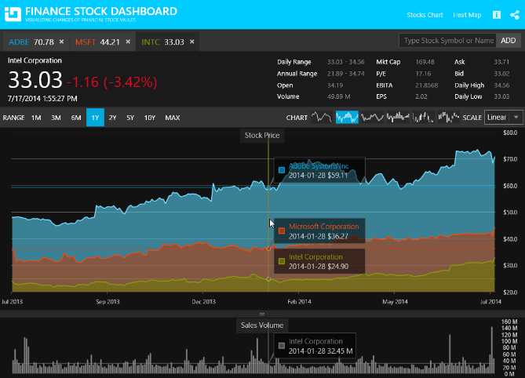
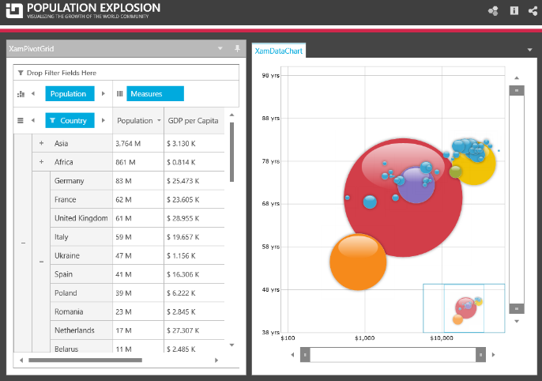

Installation
Downloading | Download Infragistics Controls for WPF here.

What’s New
Component | Feature Name | Descriptions
Excel Engine | Hyperlinks support | The data model of the library now supports creating of and operating with hyperlinks.
Excel Engine | Workbook protection | The data model of the library now allows you to protect workbooks. Workbook protection disallow adding, renaming, reordering and deleting of worksheets.
Excel Engine | Worksheet protection | The data model of the library now allows you to protect worksheets.
Combo Editor | Binding to collections of primitive types | The control supports binding to collections of primitive types such as bool, char, double etc. types. It supports also binding to enum and collections of string and DateTime data.
Combo Editor | Configuring the minimum drop-down height | A new property MinDropDownHeight is added to provide functionality for configuring the minimum drop-down height of the xamComboEditor control.
MultiColumn Combo Editor | Configuring the minimum drop-down height | A new property MinDropDownHeight is added to provide functionality for configuring the minimum drop-down height of the xamMultiColumnComboEditor control.
Data Grid | Configuring field and record resizing | The control now supports configuring the areas where fields and/or records can be resized.
Data Presenter | Binding to selected data item | The control now allows you MVVM-friendly binding to the last selected item using a property.
Gantt | Sections resizing | The control now supports resizing of the grid and chart sections.
Spreadsheet | Hyperlinks support | The control supports hyperlinks which are special text objects that can navigate the user to a specific location once clicked.
Spreadsheet | Obtain hovered cell | The control allows you to obtain a worksheet's cell by providing a point.
Spreadsheet | Multiple worksheets selection | The control allows you to select multiple worksheets and perform group operations over them.
Spreadsheet | Workbook and worksheet protection | The control support disabling of certain user functionality when workbook and/or worksheet protections are engaged.
Spreadsheet | Underline support | The control now renders underline and double-underline text.
Tree Grid | New control | The xamTreeGrid control is the latest addition to the Data Presenter family of controls. It arranges data in a tree grid layout. Essentially the control is a xamDataPresenter that implements a single view (a tree view) which cannot by dynamically switched.

What’s Changed
Components | Product Impact | Description
Calendar | Bug Fix | [Office 2010 Black Theme] The foreground of the selected CalendarItems should be changed.
Color Picker | Improvement | Caption properties are not being set when the control is placed in the ItemTemplate of an ItemsControl.  Notes:  Changes in the way that the xamColorPicker *Caption properties are initialized - the default values are added when the *Caption dependency properties are registered.
Combo Editor | Bug Fix | [Office 2010 Blue Theme] XamComboEditor doesn’t show tip text for the error info when it gets the focus.
Combo Editor | Bug Fix | Error disappears after updating the binding.
Combo Editors | Bug Fix | ArgumentException is thrown on close when a theme is set and multi-select combo editor is used.
Combo Editors | Bug Fix | Selection is not cleared when the SelectedValue property is set to an invalid value.
Combo Editors | Bug Fix | The Combo Editors drop-down height is not preserved.
Combo Editors | Bug Fix | The Combo Editors drop-down is not always displayed correctly when changing the MaxDropdownHeight in runtime.
Combo Editors | Bug Fix | Resizing does not function properly when the FlowDirection is set to RightToLeft or when in WPF the menus are right-aligned.
Combo Editors | Bug Fix | Combo Editor with wrapped text and selected items throws an exception and its popup is not correctly positioned.
Combo Editors | Bug Fix | Exception is thrown when a custom property descriptor uses type Double.
Combo Editors | Bug Fix | NullReferenceException is thrown when binding to ITypedList collection.
Data Chart | Improvement | A first chance exception of type 'System.ArgumentException' occurs when the StackedFragmentSeries are added dynamically.  Notes:  A member path scenario with drilling off of an indexer has been added to the supported member path scenarios.
Data Grid | Bug Fix | LoadCustomizations causes TargetInvocationException when resetting the data source.  Notes:  Resolved an issue in the XamDataGrid which resulted in a TargetInvocationException when a filter is active and the grid's data is refreshed with a list of items of a new dynamically created type that contains the same properties as the type in the original list.
Data Grid | Bug Fix | Filter values are not being updated after new items are added to the DataSource and the filter was previously opened.  Notes:  Resolved an issue in the XamDataGrid/XamDataPresenter where the unique data values displayed in the FilterCell dropdown were not refreshed when the underlying items source was changed.
Data Grid | Bug Fix | IndexOutOfRangeException is thrown when adding sorted fields before loading.
Data Grid | Bug Fix | The Field IsReadOnly property throws NullReferenceException.  Notes:  Resolved a NullReferenceException that occurred when accessing the value of the Field.IsReadOnly property if the property had never been set (i.e., contained its default value of null).
Data Presenter | Bug Fix | RowNotInTable exception is thrown for each row when reloading a data table with summaries activated.
Data Presenter Record Filtering | Bug Fix | Incorrect filter dropdown items with ComboBoxField.  Notes:  Resolved an issue in the XamDataGrid which could occur when using the new ComboBoxField field type introduced in 14.2. In certain scenarios, the dropdown in the FilterCell associated with a ComboBoxField could erroneously contain unique data values from another column.
Data Tree | Bug Fix | When editing a xamDataTree item, the text box is not styled in themes.
Data Tree | Bug Fix | The node's IsEnabled visualization is not reflected properly when it is set from the view model.
Data Tree | Bug Fix | A node without a child node does not accept a dropped node unless the node previously had a child node.
Data Tree | Bug Fix | Performance issue appears when checking all nodes.
Date Navigator View | Bug Fix | [Metro Dark Theme] Week Number is not clearly visible when there is a selection.
Date Navigator View | Bug Fix | [Metro Dark Theme] Week Number selection is not styled.
Date Time Editor | Bug Fix | Alignment inconsistency in the themes for xamDateEditor.
Date Time Input | Bug Fix | Validation error is not displayed when ErrorsChanged is invoked.
Diagram | Bug Fix | The Resize handles are no cleared when clearing the Items collection.
Diagram | Bug Fix | Connection Points are still visible after clearing the items.
Diagram | Bug Fix | Position resets to (0, 0) on resize if bound.
Dialog Window | Bug Fix | KeyTips are shown when a modal dialog is opened.
Dialog Window | Bug Fix | IsDefault button on a window is still clicked when pressing Enter if the modal dialog window is open.  Notes:  Even though the fix prevents the original default button from clicking, there is no way to use a second button with IsDefault property in the XamDialogWindow, as it does not inherit from Window.
Dock Manager | Bug Fix | A content pane in TabGroupPane with IsPinned set to "False" does not unpin on startup.
Drag and Drop Framework | Bug Fix | A third party ScpEnhancedImageControl cannot be dropped.
Gantt | Bug Fix | Invalid JP date format in a Gantt sample.
Geographic Map | Bug Fix | The GeographicSymbolSeries do not load.
Grid | Bug Fix | InvalidCastException is thrown when accessing the GroupByRow’s ChildBands.  Notes:  The GroupByRow ChildBands collection property is changed to return null because it is not supported by design for a row of type GroupByRow.
Grid | Breaking Change (Other) | Cannot change a Hidden column's visibility by using the column chooser if a column belongs to a group column.  Notes:  Until now, when you try to collapse the last visible column in a group, its parent column is collapsed and the child column remains visible. Now, this behavior is changed – if you collapse the last visible child column - it is collapsed as well as its parent column.  The other change is when you switch the visibility of a parent column from collapsed to visible – the parent column becomes visible as well as all its children columns.
Grid | Bug Fix | Application crashes when the control is in a ChildWindow and the AllowToolTips property is set to Overflow.
Grid | Bug Fix | Selected row occasionally changes as the row order is changed by drag and drop operation.
Grid | Bug Fix | NullReferenceException is thrown on bound data PropertyChanged notification.
Grid | Bug Fix | NullReferenceException is thrown, when clearing the filter through the clear filter button after ungrouping.
Grid | Bug Fix | The filter menu shows the items of ComboBoxColumn using the SelectedValuePath.  Notes:  A new converter property named FilterMenuItemConverter of type IValueConverter is added for the xamGrid ComboBoxColumn and MultiColumnComboColumn to provide an easy way for converting the displayed items text in the filter menu.
Grid | Bug Fix | [Metro Dark Theme] Fixed column's drop area is not visible.
Grid | Bug Fix | A row is added after ending edit mode in the FilterRow.
Grid | Bug Fix | The horizontal scroller stays visible after resizing the window when there are only Fixed columns.
Grid | Bug Fix | NullReferenceException is thrown when changing the theme after showing the filter menu.
Grid | Bug Fix | Memory leak when a filter is applied and the parent window is closed.
MultiColumn Combo | Bug Fix | [Metro Dark Theme] The editor caret is not visible.
MultiColumn Combo | Bug Fix | xamMultiColumnCombo does not keep the foreground of the selected item when hovered.
MultiColumn Combo | Bug Fix | Inconsistent scrolling behavior when one row has wrapped content.  Notes:  The main scrolling problem of items with different height is resolved but there still could be seen some undesired blinking when scrolling due to the virtualization in the XamComboEditor.
Pivot Grid | Bug Fix | The CellEdited event does not fire when the application is being closed.  Notes:  The xamPivotGrid doesn't automatically save the unsaved changes on window closing. The desired behavior can be achieved handling the window closing event as follows:  private void Window_Closing(object sender, System.ComponentModel.CancelEventArgs e)  {  var control = pivotGrid.EditSettings.Editor as PivotEditControl;  if (control == null)  return;  if (control.IsInEditMode)  {  control.ExitEditMode(true, false);  }  }
Pivot Grid | Bug Fix | ArgumentNullException is thrown when loading customizations with hierarchy which no longer exists in the data source.
Pivot Grid | Bug Fix | The ResultChanged event is not raised when loading a large amount of data.
Ribbon | Bug Fix | Error validation is broken on tab changing.
Ribbon | Bug Fix | The Quick Access Toolbar is hidden after changing the theme through the application menu.
Rich Text Editor | Bug Fix | Title numbering is lost when a word document is exported to RTF.  Notes:  Fixed an issue with the RTF saving of the RichTextDocument where the list numbers might not appear correctly when the file is opened.
Rich Text Editor | Bug Fix | Font is not applied to Japanese text.  Notes:  Fixed an issue with the RichTextDocument where Japanese text was not getting affected when applying a font to the current selection.
Rich Text Editor | Bug Fix | Image is not exported to RTF.  Notes:  Fixed an issue with the RichTextDocument where RTF files saved and opened in WordPad on a Windows 7 machine would not display images.
Schedule | Bug Fix | The reminder combo box is not styled in all themes except the Metro Dark theme.
Schedule | Bug Fix | [Office 2013 Theme] The selection of reminder ComboBox in the activity dialog should not have borders.
Schedule | Bug Fix | NullReferenceException is thrown multiple times when null DateRecurrenceRuleBase is added to the Rules collection.  Notes:  Fixed an issue in the Schedule library where null entries were allowed to be added to the DateRecurrence.Rules collection.
Spread Sheet | Bug Fix | Columns with locked cells can be deleted from a protected sheet when column deletions are explicitly allowed.
Spread Sheet | Bug Fix | The selection is not properly spread to all cells when made for multiple selected sheets with merged cells.
Spread Sheet | Bug Fix | Context Menu is not shown for Select All button in the xamSpreadsheet.
Spread Sheet | Bug Fix | Links can be added by typing in an unlocked cell when a worksheet is protected and inserting of hyperlinks is not allowed.
Spread Sheet | Bug Fix | Deleting all cells when all rows and columns are selected is not resetting the column settings like width and format.
Spread Sheet | Bug Fix | Copy-pasting a whole worksheet from excel to a spreadsheet is a slow operation.
Theme Manager | Bug Fix | The 2014.2 public source code does not include the Theme Manager folder.  Notes:  The "Source Code" package is updated with the necessary theme projects. They should be located in "ThemeManager" folder.

