INFRAGISTICS WPF 17.2 –
Volume Release Notes – 2017

Raise the Bar on Both BI and Desktop UI with Infragistics WPF Controls

Infragistics WPF controls provide breadth and depth in enabling developers to bring modern, trend-setting applications to market while shortening development time. If you need gesture/touch support, dynamic themes, and lightning fast performance in one WPF package, look no further.
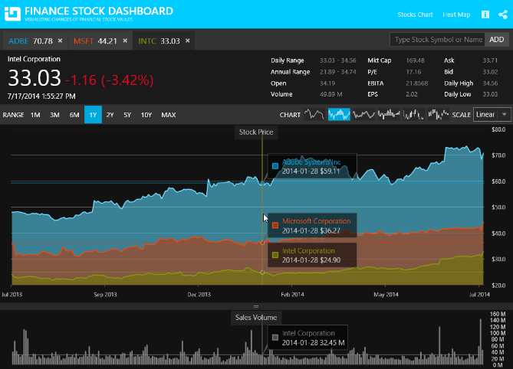
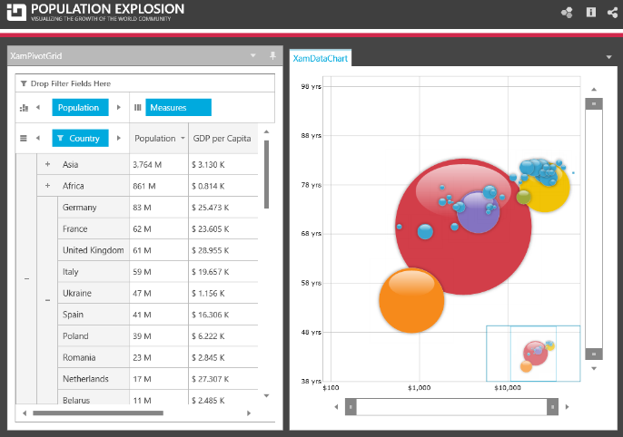
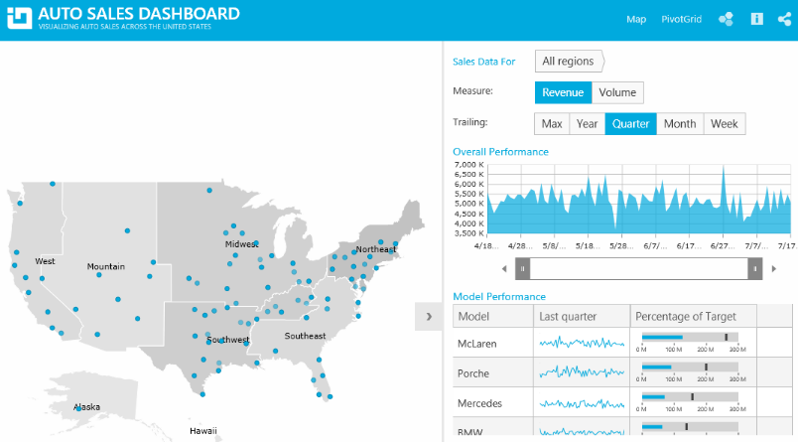

Installation
Downloading | Download Infragistics Controls for WPF here.

What’s New
Component | Feature Name | Descriptions
All | Royal Light Theme | The Royal Light theme is a consistent and simplified new theme enriched with more visual states, featuring improved UX and light colors.
Data Presenter Family of Controls | Performance Improvements | The SimpleTextBlock, which is found in the editor templates found in cell templates, now uses GlyphRun instead of FormattedText. This leads to significant performance improvements when rendering the cell’s text.
Shape Chart | New Control | The XamShapeChart is a lightweight, highly performant chart. This chart can be easily configured to display scatter X/Y points or data items with at least 2 numeric data columns. The chart can also plot data from shape files as either Polygon or Polyline visualizations. In addition, you can plot any custom shape by using a list of lists of Point objects with X/Y properties.
Scatter Chart (CTP) |  | The XamScatterChart is lightweight, high performance chart with an extremely simple and intuitive API.  The main difference from the XamShapeChart control is that it does not support complex visualizations such as Polygon and Polyline. It supports simple visualizations (Area, Bubble, Contour, High Density, Point, Line, and Spline) that you can use to display X/Y data.
Data Chart | New Scatter Series | There are four new types of scatter series added to the XamDataChart control:  - ScatterAreaSeries  - ScatterContourSeries  - ScatterPolygonSeries  - ScatterPolylineSeries
Data Chart | New TimeXAxis | A new TimeXAxis is added to the XamDataChart. By default, this axis will automatically apply label formats, which dynamically change as the user zooms into data. In addition, the axis breaks may be configured to omit dates within a range.

What’s Changed
Work Item ID | Components | Product Impact | Resolved date | Description
243008 | Barcode Reader | Bug Fix | 29-09-17 | Some pictures taken with a webcam cannot be decoded.
242219 | Busy Indicator | Bug Fix | 13-09-17 | It is possible to tab into elements that are children of the XamBusyIndicator while it is busy.
241639 | Category Chart | Bug Fix | 28-08-17 | Category Chart XAxisTitleOpacity and YAxisTitleOpacity have incorrect default values, currently 0, should be 1.
241281 | Category Chart | Bug Fix | 18-08-17 | XamCategoryChart Background property has no effect.
242661 | Color Picker | Bug Fix | 25-09-17 | Binding error occurs when the SelectedColor property is set to null.
238926 | Color Tuner | Bug Fix | 17-07-17 | Color Tuner is not properly installed in the Visual Studio 2017.
230815 | Combo Editor | Bug Fix | 28-07-17 | [Metro Theme] xamComboEditor is not respecting the min-dropdown height.
239963 | Combo Editor | Bug Fix | 24-07-17 | XamComboEditor does not select the focused item when pressing the Tab key.
240777 | Combo Editor | Bug Fix | 11-08-17 | When the ComboEditorItemControl elements are trigger-styled according to a DataItem property in the XamComboEditor, random elements is styled.
234718 | Combo Editor | Bug Fix | 08-09-17 | [Office2013 Theme] Scrollbar on dropdown appears for a second time and later it opens.
242773 | Combo Editor | Bug Fix | 26-09-17 | XamComboEditor's focus border is not visible.
239138 | Combo Editors | Bug Fix | 29-06-17 | Binding to SelectedItems in DataTemplate does not propagate back to view model.
234202 | Combo Editors | Bug Fix | 17-07-17 | Cross-Platform XamComboEditor issues with VSM states.
227652 | Combo Editors | Bug Fix | 15-09-17 | Drop-down list size (width and height) is not calculated correctly when the Office2013 theme is applied.
241454 | Data Chart | Bug Fix | 23-08-17 | Adding an axis to series before adding a chart causes NullReferenceException.
241575 | Data Chart | Bug Fix | 29-08-17 | Different behavior with logarithmic numeric axes when targeting 64-bit versus 32-bit when plotting values that are less than 1, but greater than 0.  Notes:  Adjusted the logarithmic code so that it will work correctly in 64bit mode.
242889 | Data Chart | Bug Fix | 22-09-17 | TimeXAxis can't see the axis line.
238291 | Data Grid | Breaking Change (API) | 30-06-17 | The e.DropDownItems argument of the RecordFilterDropDownPopulating only contains the built-in filter items.  Notes:  New event is added in the XamDataPresenter called RecordFilterDropDownPopulated. Raised after the filter drop-down is populated by the data presenter, giving you a chance to replace the filter drop-down with your own items or remove some of them.
238413 | Data Grid | Bug Fix | 22-06-17 | XamDataGrid's Filter Operator is not displayed when only one Operator is set.
240171 | Data Grid | Bug Fix | 26-07-17 | The BindingPath and AlternateBinding's path affects the loading of customizations.
239761 | Data Grid | Bug Fix | 01-08-17 | Blanks operand in MultiSelectExcelStyle should include white-space only strings.  Notes:  Now the whitespaces are treated as "(Blanks)" and the filter operand will filter them in or out.
241250 | Data Grid | Bug Fix | 22-08-17 | [Royal Dark Theme] Styling the DataRecordCellArea's Background property has no effect.  Notes:  Updated DataRecordCellArea Style.
241479 | Data Grid | Bug Fix | 07-09-17 | Error appears when setting the IsScrollTipField property in design time.
241724 | Data Grid | Bug Fix | 07-09-17 | [Royal Dark Theme] The CellValuePresenter foreground is respected only on cells with certain editors.
241725 | Data Grid | Bug Fix | 07-09-17 | [Royal Dark Theme] Foreground property for CellValuePresenter style does not do anything.
242288 | Data Grid | Bug Fix | 15-09-17 | Grouping and sorting operations, and loading customizations with those operations with a large amount of records is slow.
242731 | Data Grid | Bug Fix | 22-09-17 | When SortEvaluationMode and GroupByEvaluationMode are both set to "UseCollectionView" and there are multiple groups, sorting collapses the groups.
242826 | Data Grid | Bug Fix | 22-09-17 | StackOverflowException is thrown when using Records.ExpandAll(true).
239217 | Data Grid | Bug Fix | 26-09-17 | XamDataGrid's BeginUpdate and EndUpdate methods cause IndexOutOfRangeException.
242791 | Data Grid | Bug Fix | 28-09-17 | NullReferenceException is thrown when loading a grid and resizing the containing pane in XamDockManager.
239738 | Data Presenter | New Functionality | 26-07-17 | Load customizations does not restore the column ordering when their order has been saved on application start.  Notes:  Added 'saveFieldPositionInfoAlways' parameter to xamDataPresenter's SaveCustomizations method. If it is set to true, this will address this issue.
241326 | Data Presenter | Bug Fix | 24-08-17 | [Royal Theme] Missing right border of a field that is dragged from the header area of the DataGrid or from the FieldChooser.
242582 | Data Presenter | Improvement | 19-09-17 | Loading customizations method fails after a field has been removed even if a FieldLayout Key has been supplied.  Notes:  Added overloads to LoadCustomizations method off DataPresenterBase that take a new boolean parameter named 'useStrictFieldMatching'. If not specified, it defaults to false. If 'false' will match a FieldLayout whose Key has been set to a unique value even if some or all the Fields that were present when the SaveCustomizations method was called are no longer present at the time of the load.
242943 | Data Presenter | Bug Fix | 26-09-17 | Index out of Range Exception is thrown when adding child records after using GroupBy.
237322 | Data Presenter ExcelExporting | Bug Fix | 22-06-17 | ArgumentNullException is thrown just by creating a DataPresenterExcelExporter instance when trial dlls are used.
241328 | Data Presenter Field Chooser | Bug Fix | 22-08-17 | [Royal Theme] Unnecessary border of the fields in FieldChooser when the theme is washed.
241411 | Data Presenter Field Chooser | Bug Fix | 22-08-17 | [Royal Theme] Incorrect/missing icon for indeterminate state of "All fields" checkbox in FieldChooser.
240671 | Data Presenter Fixed Fields | Bug Fix | 08-08-17 | Cells do not reposition after increasing and decreasing the FixedFieldSplitter width.
241891 | Data Presenter Fixed Fields | Bug Fix | 28-09-17 | [Royal Theme] Field fixing does not work when it is set to 'Near' or 'Far'.
204307 | Data Presenter Record Filtering | Bug Fix | 10-08-17 | Incorrect caret placement in ExternalFiltering when window is in Maximized state.
228269 | Data Tree | Bug Fix | 11-07-17 | Incorrect nodes are displayed when having a sibling node layout and using the IsExpandedMemberPath property.
238470 | Data Tree | Bug Fix | 17-07-17 | Selection\Multiple selection in XamDataTree does not work properly when the IsSelectedMemberPath is set.
241420 | Data Tree | Bug Fix | 30-08-17 | NullReferenceException is thrown in GetDataItem method of NodesManager, NodeLayout returns null.
242642 | Data Tree | Bug Fix | 19-09-17 | Selected items range is not properly updated when selecting/deselecting using Shift.
241276 | Date Time Editor | Bug Fix | 27-09-17 | XamDateTimeEditor's mask doesn't display hour when date is set and Chinese or Japanese regional settings are used.
241524 | Date Time Editor | Bug Fix | 29-09-17 | [IG Theme] The pin in the drop-drown button is not centered.
239328 | Diagram | Bug Fix | 07-07-17 | DiagramConnection is added to the node’s OutgoingConnections collection even if ItemAdding event is canceled.
234610 | Dock Manager | Improvement | 31-05-17 | SplitCursor appears invisible on higher resolutions (eg. 3200x1800 )  Notes:  A new property named ScaleCursorWithDpi has been added to the Utilities static class. By default, the property is true. When true and running on a system with .NET 4.6 or later, custom cursors loaded using the Utilities class' LoadCursor method (which includes the Infragistics WPF controls like xamDockManager) will be constructed using the constructor for Cursor that takes a boolean for 'scaleWithDpi'.
235835 | Dock Manager | Bug Fix | 27-07-17 | [Metro Theme] TabPaneItem's Header text disappears when loses unfocused.  Notes:  Selected state has been updated.
240343 | Donut Chart | Bug Fix | 01-08-17 | [Royal Dark Theme] Doughnut chart when used with hierarchical ring series has only one "child band" shown up.  Notes:  An issue was found where doughnut charts with the royal dark theme would obscure some slices. This has been corrected.
239973 | Donut Chart | Bug Fix | 28-07-17 | Doughnut Chart does not display multiple series when using Metro Dark Theme.
238340 | Donut Chart | Bug Fix | 12-06-17 | No outline is visible in WF version of Doughnut Chart.
243170 | Donut Chart | Bug Fix | 04-10-17 | The value produced by BindingExpression is not valid for target property IsSurfaceInteractionDisabled.  Notes:  Arc was binding to a version of the IsSurfaceInteractionDisabled property that was nullable while the Arc property was not nullable which produced the binding error. The nullable version has been replaced with a non nullable version so the binding now works. This was only done in 17.2 version as changing this in the earlier versions would be a breaking change for the existing applications.
239758 | Drag and Drop Framework | Bug Fix | 20-07-17 | DragSource cannot be dropped onto the drop target if the application runs in debug mode.
241592 | Drag and Drop Framework | Bug Fix | 01-09-17 | Dragging icon becomes X when the dragged item goes over a hidden window.
242541 | Drag and Drop Framework | Bug Fix | 18-09-17 | Legend does not get large enough to show all legend items once it is dragged and dropped.
228105 | Excel | Bug Fix | 24-05-17 | CellFormat returned by GetResolvedCellFormat holds incorrect BorderStyle values.
239806 | Excel | Bug Fix | 18-07-17 | FormulaParseException is thrown when loading an Excel file.
239691 | Excel | Bug Fix | 12-07-17 | Cell borders are not copied when rows and columns are inserted in 97-2003 workbook.
241532 | Excel | Bug Fix | 24-08-17 | Fractions are strangely reduced once the cell is commited.
239579 | Excel | Bug Fix | 11-07-17 | Worksheet remains selected after its Visibility is changed to Hidden.
240989 | Excel | Bug Fix | 29-09-17 | Merged cell's vertical alignment becomes Center after loading and saving the workbook.
238740 | Gantt | Bug Fix | 22-06-17 | ProjectTask presenters can get too small to a point where they cannot be dragged.
238885 | Gantt | Bug Fix | 26-06-17 | InvalidOperationException is thrown when setting XamGantt row cell's IsEnabled property and Office 2013 or Royal Dark theme are set.
240843 | Gantt | Bug Fix | 23-08-17 | ProjectCalendar.ToExceptionsXml throws InvalidOperationException when more than one ProjectCalendarException is present.
240765 | Gantt | Bug Fix | 23-08-17 | Parent task's Start and Finish properties have wrong values when its child task's PercentComplete is 100%.
242070 | Gantt | Bug Fix | 07-09-17 | ProjectCalendar ToExceptionsXml method does not save the rules associated with the recurrence.
221516 | Gauges | Bug Fix | 20-09-17 | Some gauges do not render correctly when over 20 gauges are present in the application.
239701 | Geographic Map | Bug Fix | 19-07-17 | InvalidCastException is thrown when adding points to ObservableCollection.  Notes:  An issue was found in updating data at runtime for ShapeSeries when the data items are of type IEnumerable<Point>. This has been corrected.
239469 | Grid | Bug Fix | 11-07-17 | XamGrid freezes while resizing with GridSplitter and TextWrapping/Sized fields.
240355 | Grid | Bug Fix | 09-08-17 | FilterValue text box in Custom Filter Dialog does not accept IME composition string when Keyboard DefaultRestoreFocusMode property is set to None.
240354 | Grid | Bug Fix | 09-08-17 | Text box in filter menu does not accept IME composition string when Keyboard DefaultRestoreFocusMode property is set to None.
241564 | Grid | Bug Fix | 25-08-17 | NullReferenceException is thrown in XamGrid when the close button of GroupByHeaderCellControl is pressed and ItemSource is of type CollectionView.
241520 | Grid | Bug Fix | 24-08-17 | Horizontal scrollbar disappears when the vertical scrollbar is moved.
237864 | Grid | Bug Fix | 19-09-17 | When XamGrid's ItemsSource is bound to a DataTable's DataView, adding new columns to the table does not update the UI.
242756 | Grid | Bug Fix | 25-09-17 | Data columns in a group column are not properly laid out after moving.
236756 | Multi Column Combo | Bug Fix | 31-07-17 | [Royal Dark Theme] The highlighted text in the XamMultiColumnComboEditor is hardly readable when the Royal Dark theme is applied.
236974 | Multi Column Combo | Bug Fix | 31-07-17 | [Royal Dark Theme] The vertical text alignment in Royal Dark theme is inconsistent with the other themes.
238656 | Pie Chart | Bug Fix | 21-06-17 | Initially selected slice(s) is styled incorrectly (slice fill is wrong).
238657 | Pie Chart | Bug Fix | 21-06-17 | Slice selected programmatically using multiple selection can’t be deselected.
239140 | Pie Chart | Bug Fix | 21-09-17 | Changing the pie chart selection from multiple to single results in multiple selected items.
239143 | Pie Chart | Bug Fix | 21-09-17 | Changing the pie chart selection from single to multiple results in losing the initial selection when selecting value after the change.
239145 | Pie Chart | Bug Fix | 22-09-17 | Changing others threshold to move selected slice into others slice or add unselected items to selected others slice causes selected item not to reflect all data items in others slice
227562 | Pie Chart | Improvement | 26-09-17 | Legend shows the same text as pie chart slices which defeats the purpose of a legend.  Notes:  LegendLabelMemberPath is added to the WPF XamPieChart to allow users to specify different text for the legend items more easily.
239818 | Pivot Grid | Bug Fix | 18-07-17 | StackOverflowException is thrown when the control is being saved by System.Windows.Markup.XamlWriter.Save method.
239846 | Property Grid | Bug Fix | 26-09-17 | Scrolling quickly when the PropertyGridPropertyItemView's Visibility is bound results in NullReferenceException.
242739 | Property Grid | Bug Fix | 02-10-17 | FilterAreaVisibility property is not respected in the MetroDark theme.
240203 | Property Grid | Bug Fix | 03-10-17 | When placed in an unpinned pane in XamDockManager, the pane closes while property grid is still in use.
243773 | Property Grid | Bug Fix | 09-10-17 | Properties of type IEnumerable are not expandable.  Notes:  Added support to XamPropertyGrid for displaying properties of type IEnumerable as expandable properties that show the IEnumerable contents within.
229806 | Ribbon | Bug Fix | 23-06-17 | Misaligned icons appear in the Non-client area of maximized XamRibbonWindow.
238768 | Ribbon | Bug Fix | 22-06-17 | NullReferenceException occurs at startup if more tools are placed in a RibbonTab than can fit.
210829 | Ribbon | Bug Fix | 18-07-17 | Error appears in the VS Output when Metro or Metro Dark theme is applied.
241491 | Ribbon | Bug Fix | 23-08-17 | RibbonTabItem is set as the ActiveItem when in active item navigation mode when tabbing between non-tool elements in a RibbonGroup
213541 | Ribbon | Bug Fix | 30-09-17 | Style ribbon group is not displayed properly after resizing the window.
224853 | Ribbon | Bug Fix | 29-09-17 | The KeyTips in the XamRibbon is not restyled when using different themes.
227432 | Ribbon | Bug Fix | 29-09-17 | The rectangle part of the QAT's Dropdown area disappears when the DialogBoxLauncher of any RibbonGroup is set through XAML.
238062 | Rich Text Editor | Bug Fix | 13-07-17 | Pressing End key, before paragraph mark, navigates to the previous paragraph.  Notes:  Resolved an issue with improper handling of the 'End' key when the key is pressed and there is no active selection. Previously, in this scenario, the caret would be positioned at the end of the previous line - with this fix it is now correctly positioned at the end of the same line.
239890 | Rich Text Editor | Improvement | 26-07-17 | InsertTableRow takes a lot of time when you have to insert more than 200 rows.
239571 | Rich Text Editor | Bug Fix | 26-09-17 | Table cells are overlapping when TableExtentBehavior is set to FitColumnsToContent.
230395 | Schedule Schedule View | Improvement | 23-08-17 | Memory Leak: Continuously updating Appointments.
242498 | Slider | Bug Fix | 14-09-17 | MinValue does not update properly, when DataContext has been changed.
240895 | Spread Sheet | Bug Fix | 09-08-17 | Auto-sizing of a row with height -1 does not force a reevaluation of the resolved height.
241566 | Spread Sheet | Bug Fix | 26-08-17 | Cell's horizontal alignment is not reset after unmerging via "MergeCellsAndCenter".
241567 | Spread Sheet | Bug Fix | 25-08-17 | A cell with ShrinkToFit set to True does not wrap after using Alt + Enter.
241568 | Spread Sheet | Bug Fix | 25-08-17 | Typing '+[integer]' followed by a fractional value is considered as an invalid formula.
240813 | Spread Sheet | Bug Fix | 22-08-17 | InvalidOperationException is thrown when Workbook contains cells that use Japanese specific display format.
240116 | Spread Sheet | Bug Fix | 25-09-17 | Cell format is not copied properly when a merged cell is copied and pasted.
240186 | Spread Sheet | Bug Fix | 22-09-17 | Custom shapes are not displayed properly.
243200 | Spread Sheet | Bug Fix | 29-09-17 | CellFormat is not copied and pasted properly.
217773 | Spread Sheet | Bug Fix | 03-10-17 | An exception is thrown when trying to hide columns through dragging the last column.
217772 | Spread Sheet | Bug Fix | 02-10-17 | Not able to select the previous column if only one is visible.
227882 | Syntax Editor | Bug Fix | 29-08-17 | The Japanese characters contained in an external file become garbled when it is loaded into the editor.  Notes:  Resolved an issue with xamSyntaxEditor and TextDocument that caused the files encoded as 'Japanese(Shift-JIS)' to be incorrectly formatted on initial load.
241614 | Syntax Editor | Bug Fix | 28-08-17 | [Royal Dark Theme] The text from the current line of the XamSyntaxEditor is unreadable when it is highlighted with the default brush.
241150 | Syntax Editor | Bug Fix | 22-09-17 | Writing a comment between the lines when using the Custom XML Language from the Samples Browser results in an IndexOutOfRangeException.
232676 | Themes | Improvement | 27-07-17 | Inconsistences between XamComboEditor and WPF ComboBox when Metro theme is applied.  Notes:  Fixed inconsistencies among all IG combo Editors and WPF ComboBox (inbox control).
242764 | Tile Manager | Bug Fix | 22-09-17 | Closing/collapsing XamTile with the close button and then setting its Visibility to Visible does not work.
242406 | Timeline | Bug Fix | 19-09-17 | Setting the width and height on time line causes long event details to be displayed with scrollbars.
239541 | Tree Grid | Bug Fix | 25-07-17 | FieldLayouts appear to be "reassigned" incorrectly after regenerating a DataSource and utilizing a previously used FieldLayout.
240070 | Tree Grid | Bug Fix | 08-09-17 | When using a hierarchy with different types, setting the DataSource to null throws InvalidOperationException.

