INFRAGISTICS WPF 16.2 –
Volume Release Notes – 2016

Raise the Bar on Both BI and Desktop UI with Infragistics WPF Controls

Infragistics WPF controls provide breadth and depth in enabling developers to bring modern, trend-setting applications to market while shortening development time. If you need gesture/touch support, dynamic themes, and lightning fast performance in one WPF package, look no further.
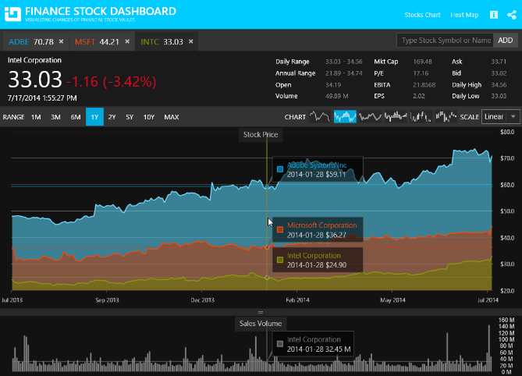
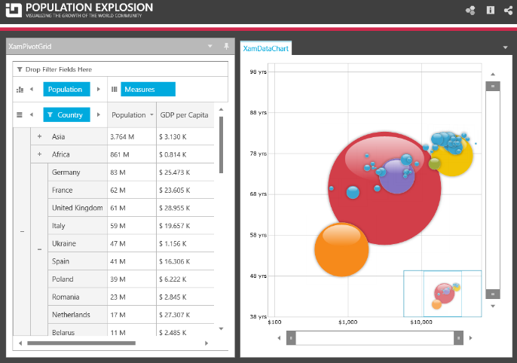
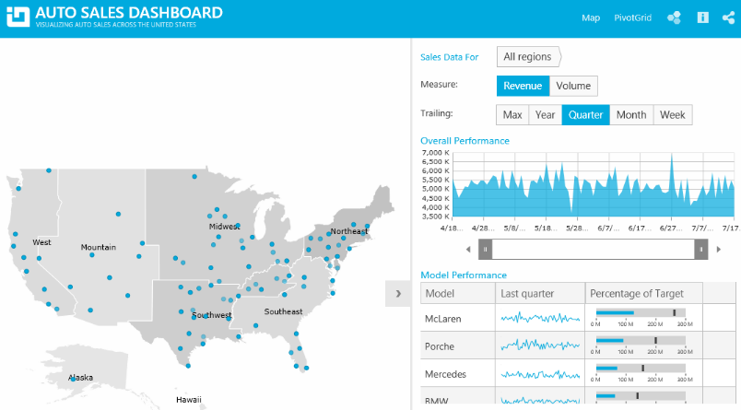

Installation
Downloading | Download Infragistics Controls for WPF here.

What’s New
Component | Feature Name | Descriptions
xamCategoryChart | New control | The xamCategoryChart can be easily configured to display category data using a simple API. All you need to do is bind your data (a collection or a collection of collections).  Built to be easily configurable, it uses the Data Chart control as its engine, which means that it benefits from the high performing and powerful Data Chart features.
xamDataChart | Performance Enhancements | The performance of the Data Chart control is significantly improved.
xamDataChart | New property ConsolidatedColumnVerticalPosition added | A new property ConsolidatedColumnVerticalPosition is introduced in order to determine the positioning logic to use for columns which have been consolidated into a single visual element.
xamDataChart | Design Changes | The defaults of the xamDataChart, xamPieChart, xamDoughnutChart, xamFunnelChart, xamRadialGauge, xamLinearGauge, xamBulletGraph and xamSparkline controls are redesigned.
xamDataChart | New Chart Series (CTP) | Two new chart series, scatter area series and scatter contour series, are added to the chart in this release. These two series are a 2D version of the 3D surface chart control.
xamGeographicMap | Legend is displayed for Geographic Map (CTP) | This CTP feature enables the Geographic Map control to display a legend.
xamShapeChart (CTP) | New control | The Shape Chart CTP control displays cartesian and geographic shapes on a chart surface. It can be used display items such as floor plans, diagrams, and maps.
xamPieChart | Slice Selection | You can now select a pie slice on the xamPieChart control. This feature is enabled by default.  We also added new selection events, some of which are cancelable, so you can stop selection of particular slices from occurring.
xamPieChart | New Event for the Pie Chart | The xamPieChart control now has a LabelClick event that fires when the labels of the pie slices are clicked.
xamPieChart | Label Coloring | You can now specify the color of the labels depending on whether they are rendered inside or outside of a pie slice. These properties are LabelInnerColor property and LabelOuterColor property.
Infragistics Excel Engine | Obtain All References for a Given Rule | The DataValidationRuleCollection now exposes a GetAllReferences method which returns a collection of references that have data validation rules equivalent to the given rule.
Infragistics Excel Engine | New Method for Comparing Data Validation Rules | The DataValidationRule now has an IsEquivalentTo method which compares this rule with the given one and returns true if the rules are structurally equivalent.
Royal Dark Theme | New Theme | The Royal Dark theme is a consistent and simplified new theme enriched with more visual states, featuring more depth and improved UX.
xamCalendar, xamMonthCalendar, xamDateTimeEditor, xamDateTimeInput | Configuring the Scrolling Direction | The xamCalendar, xamMonthCalendar, xamDateTimeEditor and xamDateTimeInput controls are exposing a new property ScrollDirection which allows you to configure the scroll direction of the calendar item group(s) when pressing the navigational arrows. Previously only horizontal scrolling was implemented.
xamDataPresenter | Cross-Field Record Filtering | The data presenter controls now support the definition of filtering rules with logical connections between them.
xamDataPresenter | Field Chooser Look | The default look of the field chooser for data presenter controls with a single field layout now includes a check box on the top for selecting all fields.
xamPropertyGrid | Data Template Selector Support for Editor Definition | The xamPropertyGrid control now supports assigning of data template selector on an editor definition.
xamRichTextEditor | New Event for the Document Adapters | All document adapters extending from RichTextDocumentAdapterBase are having a new DocumentLoadError event which is raised when an exception is thrown while attempting to load a document.

What’s Changed
Work Item ID | Components | Product Impact | Resolved date | Description
218830 | Data Chart | Bug Fix | 8/25/2016 | Data Chart throws an exception when the Extent property is set to a negative value.
224524 | Data Chart | Bug Fix | 8/31/2016 | Setting the Data Chart OPD to Visible after series rendered and zooming triggers an unhandled exception.  Notes:  An exception caused when showing the OPD later after not being initially displayed has been resolved.
215354 | Data Presenter | Bug Fix | 5/23/2016 | [PrintBasic] Text of the FieldGroup is getting outside of the background rectangle in the Field Chooser.
220415 | Data Presenter Cross Field Filtering | Bug Fix | 6/7/2016 | An exception is thrown when AllowCrossFieldRecordFiltering is set to False, AllowRecordFiltering is set to False and you are trying to edit the Field value of the filter condition.
220478 | Data Presenter Cross Field Filtering | Bug Fix | 6/8/2016 | The Operand combo box is no longer editable if AllowRecordFiltering is set to False.
222965 | Data Presenter Cross Field Filtering | Bug Fix | 8/5/2016 | The Record Selector and Filter Icons flicker when enabling and disabling cross-field filtering.
219522 | Data Presenter Field Chooser | Bug Fix | 5/20/2016 | Select all fields checkbox state is incorrect when attempting to hide the fields when they are all in field groups.
219531 | Data Presenter Field Chooser | Bug Fix | 5/20/2016 | Fields' visibility is not properly updated through Field Chooser when placed in collapsed Field Groups.
224383 | Data Presenter Fixed Fields | Bug Fix | 9/2/2016 | The Field is not fixed properly when switching from fixed to one edge to the other if LabelLocation="InCells".
225228 | Data Presenter Word Writer | Bug Fix | 9/14/2016 | DataGrid headers are not exported to Word when the LabelLocatin is set to InCells.
225107 | Date Time Editor | Bug Fix | 9/12/2016 | Vertical scrolling buttons are not rotated vertically in some of the themes of xamDateTimeEditor.
222058 | Excel | Improvement | 8/5/2016 | Method for comparing data validation rules is missing.  Notes:  Added an IsEquivalentTo method to the DataValidationRule so that rules can be compared to see if they are structurally equivalent (i.e. have the same state). Also a GetAllReferences method has been added to the DataValidationRules collection to provide a way to get all references associated with a rule that is structurally equivalent to the specified rule.
226120 | Geographic Map | Bug Fix | 9/28/2016 | Both map series mouse events and actual series mouse events are not firing for a map with Geographic Scatter Area Series.
225108 | Month Calendar Editor | Bug Fix | 9/12/2016 | Vertical scrolling buttons are not rotated vertically in some of the themes of xamMonthCalendar.
221889 | Reporting | Bug Fix | 7/26/2016 | Label TextWrapping does not occur for the Unbound Fields that span across the Data Grid's width.
221930 | Rich Text Editor | Bug Fix | 9/8/2016 | [Ctrl] + X, Delete and [Ctrl] + Z takes a lot of response time .

